

February 2026

Dear Friends
Crakehall Primary School news
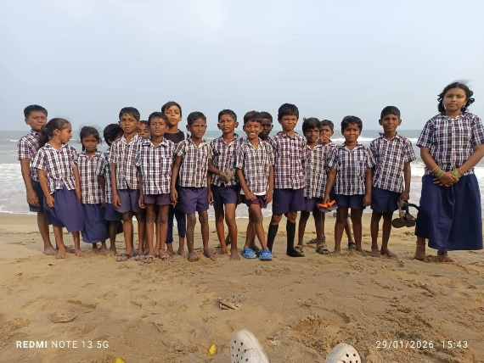
Normally our February newsletter contains information gained following Francis’ visit in January. Sadly, due to a number of issues, his visit had to be cancelled at the last minute. However, despite this, the usual activities around Pongal still took place, including a school trip. The older children were asked where they would like to go, and this year, they chose to visit the famous Marina Beach near Chennai. In order to boost the educational value, Venkat also took the school party to the Chennai museum, the recently expanded airport terminal and to see the political leaders tribute buildings. From the videos that Venkat sent, it seems the children most enjoyed the dancing on the bus!

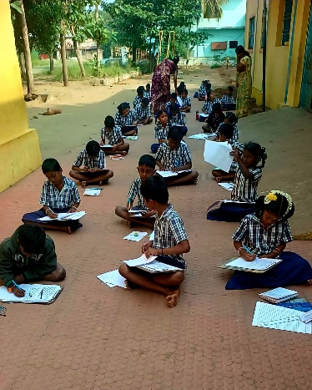
As the school starts the third and final term before the end of the school year in April, the children’s progress is again monitored with exams. Although the curriculum is very tightly defined by that term’s text books, real development and growth is enhanced through all the other activities that Venkat and the teachers organise, and this becomes apparent when our 5th year students move on to secondary school. The feedback regarding comparison with pupils from local state schools is always highly complementary and continues to show in the secondary school exam results in following years.
The school nutrition programme of a healthy lunch including breakfast for those pupils who would benefit, has been a significant part of school life for many years now and there are UK donors who specifically support this part of the project.

Health

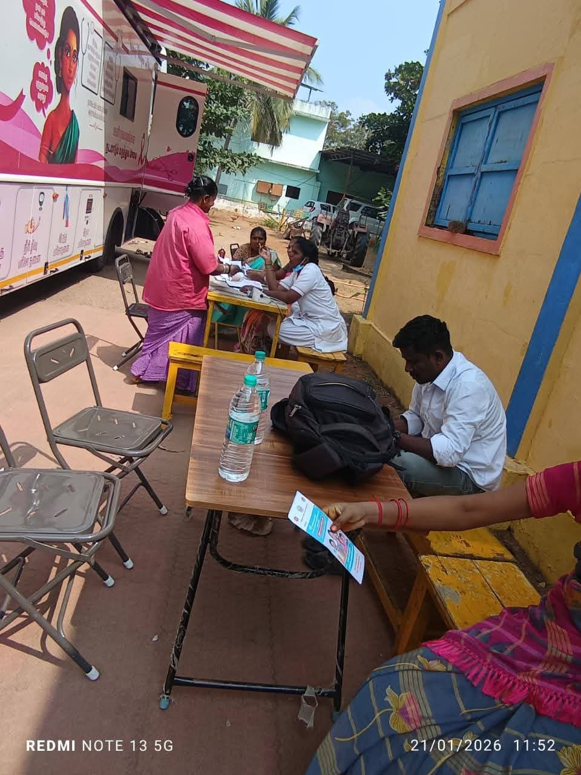
We were sad to hear that one of our teachers recently lost her mother to cancer, and this prompted Venkat to think about cancer prevention and treatment in our rural area. Contact with a local cancer specialist hospital led to a mobile cancer screening service coming to Mettupalayam. Over 50 village women came for screening and 5 have been referred to the hospital for further investigation. There is much disinformation locally regarding cancer including thoughts that it is both contagious and a curse from the gods. Education and encouragement of knowledge sharing will continue!
Next week there will be another visit by the mobile eye checkup team, undoubtedly picking up more patients requiring cataract treatment. Unlike in the UK, any operations will be carried out immediately, often the following day. These operations are all free.

Farming
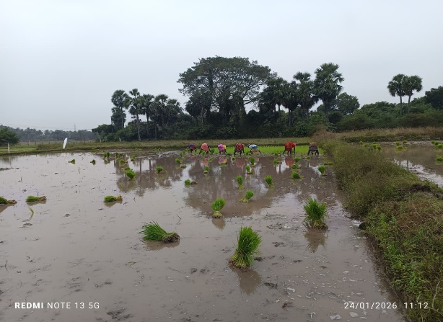
Following a good monsoon the farm has seen 5 to 6 acres of paddy planted, providing casual employment for villagers. The fruit orchards and timber trees will all benefit greatly from the rain.
The highly regarded and valued local cooperative of around 1000 small farmers continues to be a great help in lowering input costs and maximising income, and our own oil mill brings in a good income from the mainly organic oils produced and the nutritious cattle cake residue.

Finally, a huge thank you again to all our Friends who continue to support Venkat and his team. UK fundraising continues to be challenging, and we are so grateful to the many donors who show their continuing commitment and support.
Also a belated Happy New Year, as this is our first newsletter of 2026.

Contact us:
Adele Eldridge Francis and Rosie Muncaster Hugo and Jean Welsh
01969 650618 07491948878 07802641073
adeleeldridge@gmail.com fmuncaster@hotmail.com hugo.welsh30@gmail.com

