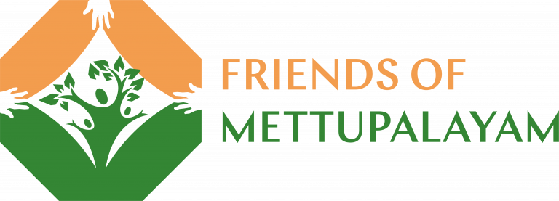
Dear Friends,
Welcome to our latest update from your rural development project in Southern India.
We are pleased to report that Venkat is in very good spirits, just back from visiting his new grandson. “I am a very lucky man”. He reports that all the distinct arms of the project (the school, healthcare, farm and nutrition-based activities and general support for the needy in the area around Mettupalayam) continue to provide a tremendous service – all thanks to your support and generosity. We thought that we would focus this pre-Christmas message around two stories that speak to the personal impact your project has made over the years and continues to make today.
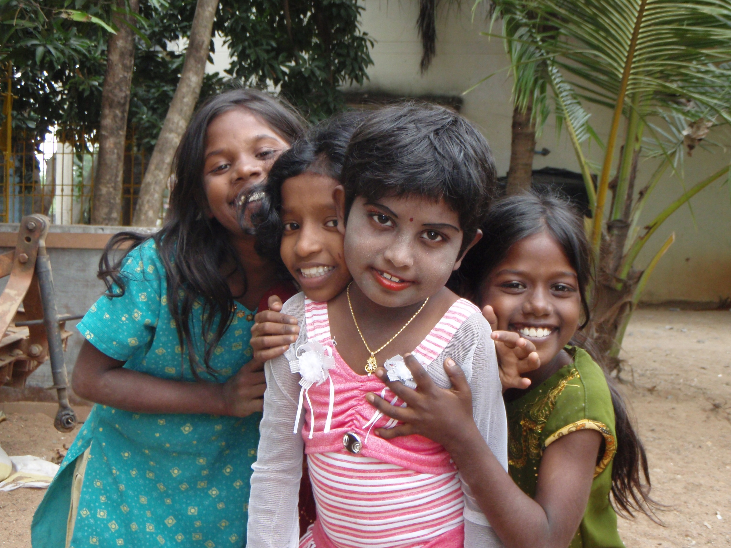
Rajeshwari. We first met Rajeshwari when she was about 4 years old. She was born profoundly deaf, but with the broadest smile you can ever imagine – she was (and is) such a joy. Living in Mettupalayam village, her mum was also deaf, and her father who is blind because of working as a welder without suitable eye protection. Her prospects looked bleak. Working with Venkat, we started to look for opportunities. Through a chance encounter at a Soroptimists event in the UK we learned about a boarding school, the Rangammal School for the hearing impaired, not very far from our project in a town called Tiruvannamalai in Tamil Nadu. Contact was made and a place was found for Rajeshwari. We well remember going there with her and her mum. It was an emotional time; mum and dad were hugely thankful, but leaving little Rajeshwari there was tough.
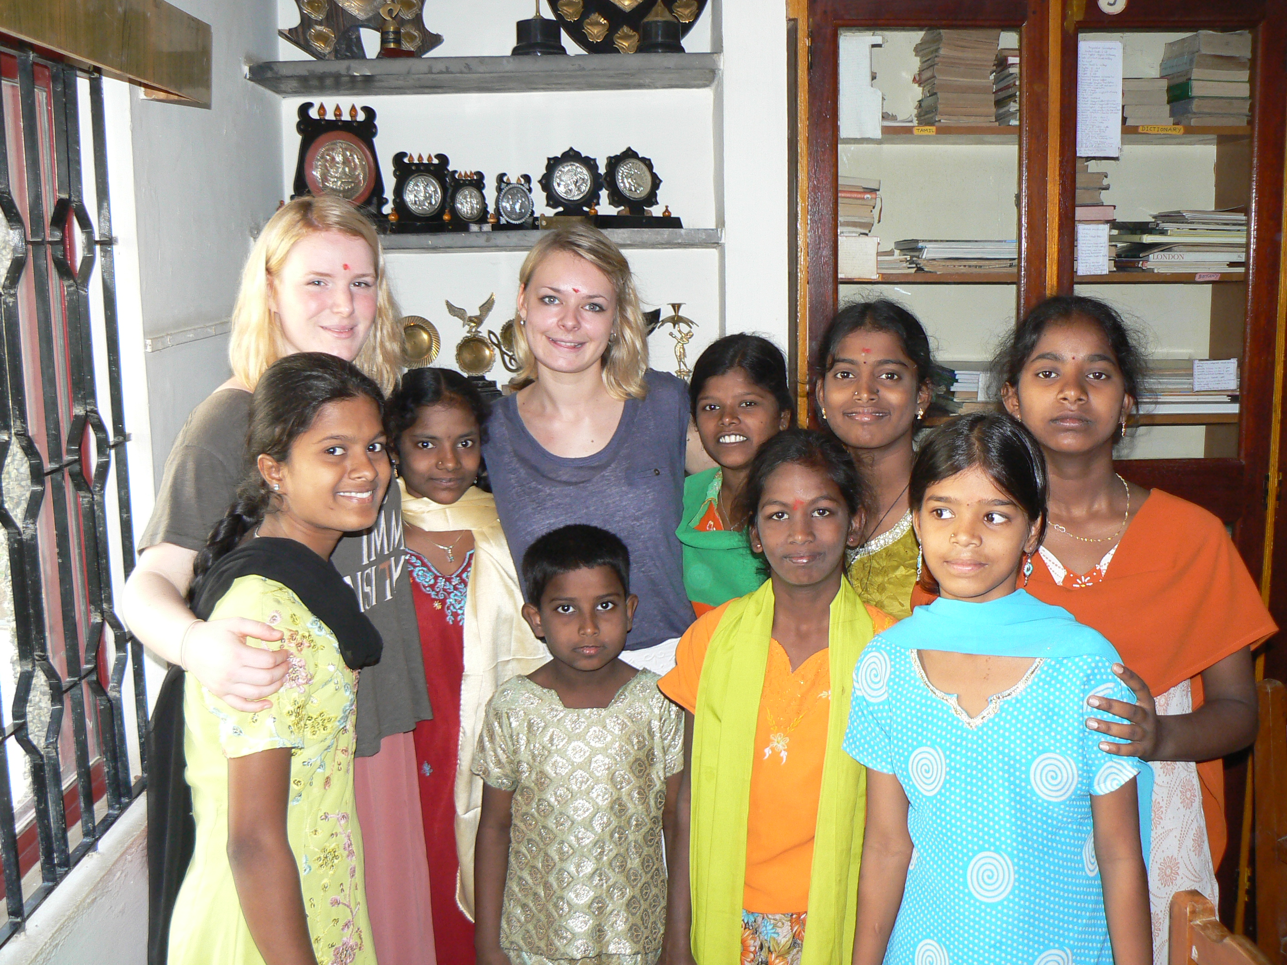
During her time at the school, we made regular visits to meet her and check on her progress. Two UK Friends’ children even went to stay and work at the school with her for a short period. Rajeshwari did very well at school and upon leaving at age 17, managed with our help to secure a place at the prestigious Presidency College in Chennai which runs a special degree programme for those with hearing disabilities. Here she met Santosh a student on the same course. They both graduated successfully last year and in September they got married. It was a wonderful day, a very happy milestone on a remarkable journey that simply could never have happened without your support.

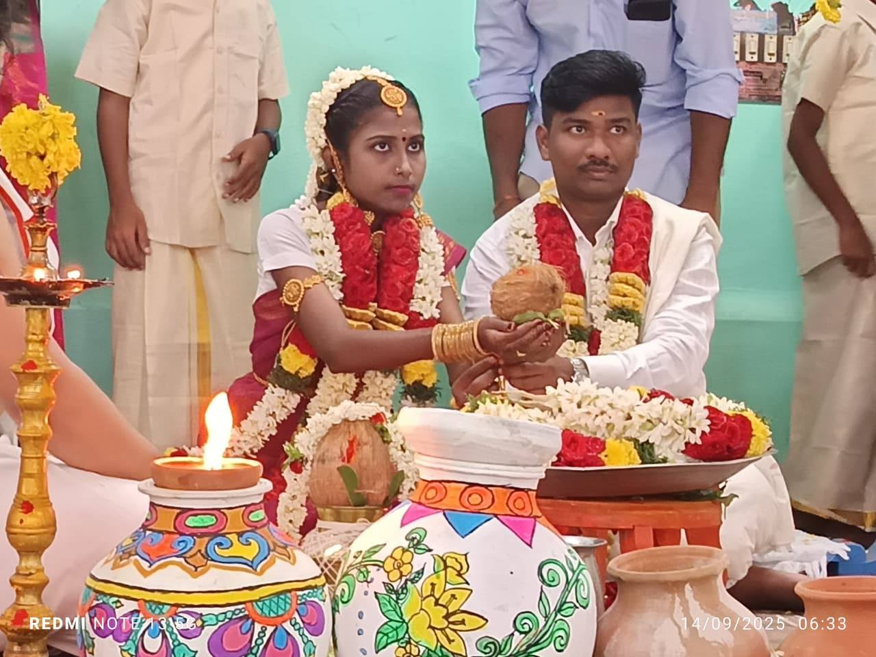
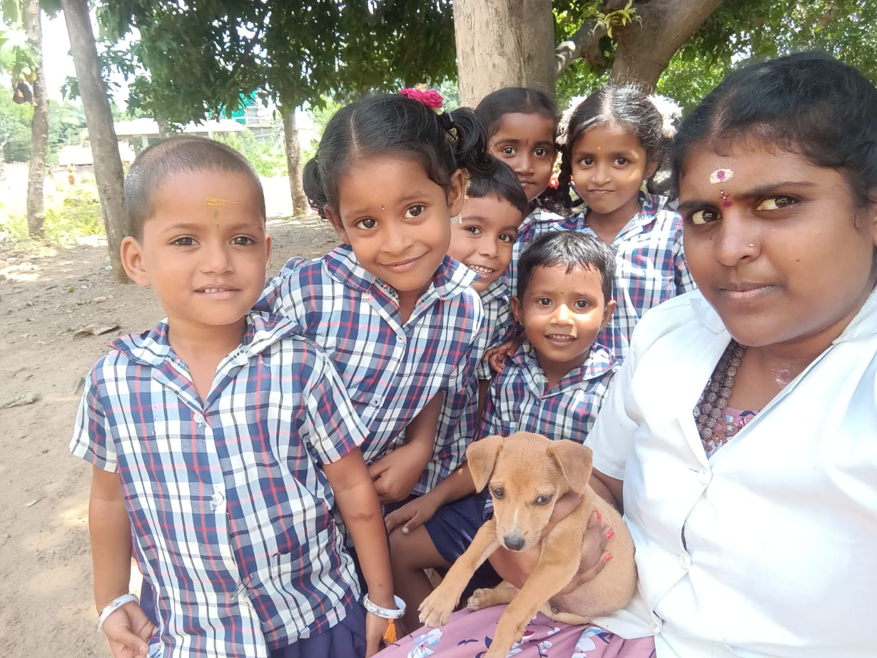
Amutha Valli Not all stories are as dramatic as Rajeshwari’s! Talking to Venkat recently, I asked him if we could talk to one of his team to get a bit of background to their connection with the project. He put me in touch with Amutha Valli. She told me that she had been a pupil at our school in Mettupalayam from age 5 to 10 yrs. She then went on to the local high school and subsequently gained a B.Ed at training college.
She now provides administrative and accounting support for the project and tells me she is delighted to be back at our school, this time not as a pupil but part of the team. She hopes to develop her teaching skills and says it has been wonderful to be warmly welcomed back. She has a passion for English and Tamil so would like to be able to focus her support in these areas. She particularly emphasises the supportive team atmosphere she has encountered at the Crakehall school.
Hers is the story of someone who benefited from her early education at our school and is now giving back to it. We plan to maintain our link with Amutha Valli and to talk to others who have been touched by the project in future newsletters. We hope that it gives a new insight into the difference your support makes.
Future Priorities
Your Trustees are meeting before Christmas to review priorities. We are very aware of the pressures on everyone’s finances and we will aim to ensure that your support is directed to where it matters most. In support of this, Francis is visiting the project again in January and we look forward to giving you his report in the new year.
We would also like to take this opportunity to thank all our Friends whose donations enable the project to continue and we are happy to send out a newsletter to any friends of Friends who may wish to help.
Once again, we wish you a very merry Christmas and a peaceful and happy 2026. Venkat sends his personal best wishes and thanks to you all.
Contact us:
Adele Eldridge Francis and Rosie Muncaster Hugo and Jean Welsh
07484 709155 07491 948878 07802 641073
adeleeldridge@gmail.com fmuncaster@hotmail.com hugo.welsh30@gmail.com

