

Dear Friends,

Welcome to our latest update from your rural development project in Mettupalayam.

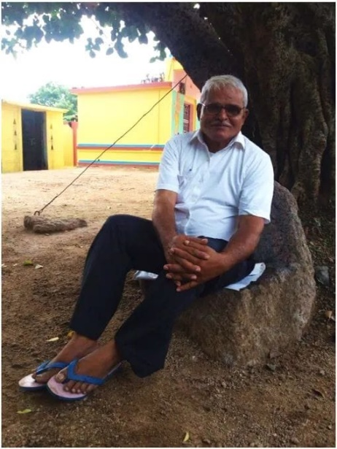**A time to reflect**

August 15th 1984 was the day Venkat, sitting on a rock, started his first lesson to a handful of young children on the dusty ground around him. From that moment and with the inspirational support of David, and then Adele, Eldridge, he has sought to make his dream a reality. The dream to bring education, and a better future to the village of Mettupalayam and its surroundings. Mettupalayam (village on a hill) was in a very poor rural area where the children received no formal education, only 1% (one person) of the population was literate, families suffered from severe malnutrition and water supply was from unsafe open wells. This photo is Venkat on that same rock 40 years on!

Because of Venkat’s tireless commitment and your unwavering and generous support, the local children now attend our Crakehall primary school and progress to higher education; illnesses linked to poverty have been almost completely eradicated (in 1984 12% of the local population had Leprosy and Tuberculosis was common); nutritious food (often supplied through our own farm) is available; safe water supplies have been provided and health support and education is a priority. And of course, there is much more which underpins a comprehensive programme of rural development.

Talking with Venkat recently he told me “I feel like one of the luckiest people in the whole of India. The generosity and friendship of all those people in the UK who have supported us in whatever way has enabled me to follow my dream. We have achieved so much, but don’t worry I have more dreams!”

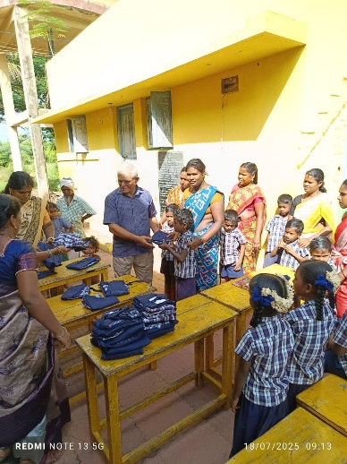**The Crakehall School**

Attendance remains healthy at between 70 and 75 pupils and all the children were recently provided with new school uniforms made by our village tailor Kanniammal. Friends may recall that Kanniammal was trained by Karen on one of her many visits. As previously advised, we increased salaries last year to aid retention and improve teacher quality. One of our newer teachers has an IT qualification and Venkat has asked her to lead computer training of the other teachers. To support this, he has invested in an interactive electronic whiteboard which links to a pc. It is planned that all the teachers will soon be able to use this with each year group. Venkat says it “should not just be the well-off children who have access to up-to-date learning aids”.

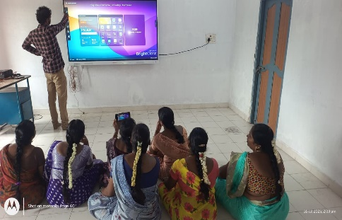Venkat will be having a break in August to visit his daughter who is having her second baby. We are delighted that he feels confident to leave the running of the school with his teaching team.

**Health**

In addition to the regular doctor visit, Venkat recently organised a health camp visit from a local Nursing College where the children and some villagers had check-ups and health advice. They have also started a free patient delivery service to a local hospital for rural people requiring treatment, a major step forward.

**Water supply and Farm**

The development of a very large quarry next to our farmland has had a significant impact on our water supply to the farm. We have therefore authorised Venkat to initiate works to deepen and improve supply from two of our existing wells. He has taken expert advice and plans for this work to commence in January, after the monsoon season.

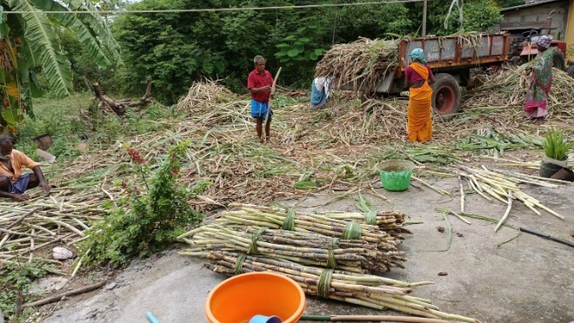In light of the water supply issue, Venkat has switched planting away from paddy to sugarcane which will require much less irrigation. He also has access to a local sugar factory and hopes this will support running costs over the next few years. We look forward to keeping you updated.

I suggested that no paddy might also be good as it would mean less water snakes, but Venkat told me that snakes are very honest creatures, so long as you don’t touch them!

**Solar Panels**

We are pleased to say that the investment in solar panels on the project building is going well, with monthly electricity running costs reduced by 85%, plus some units stored for use at higher demand times. The teachers have also been able to use this as a good educational message with the children, about energy and the climate.

**UK News**

Fundraising remains a priority in these days of financial pressures, so we were absolutely delighted by the generosity of people who attended Coffee on the Green at Poppleton, York. Our huge thanks to Rosie, Karen and Jenny. We also had generous donations from a talk given by Francis to Darlington Probus group ( a further talk has already been booked in!) and two personal donations collected by Adele.

With our recent investments in environment related projects (solar and water) we need to keep a focus on fundraising. If you can support us, we are always keen to provide information and advice. Coffee mornings are an easy and sociable option, and we have lots of project information available. Rosie and Francis are holding another coffee morning on the 17th August in Exelby, and please do come if you can.

Thank you all for your support and kindness.

**Contact us:**

Adele Eldridge Francis and Rosie Muncaster Hugo and Jean Welsh

07484 709155 07491 948878 07802 641073

[adeleeldridge@gmail.com](mailto:adeleeldridge@gmail.com) [fmuncaster@hotmail.com](mailto:fmuncaster@hotmail.com) [hugo.welsh30@gmail.com](mailto:hugo.welsh30@gmail.com)