

February 2025

Dear Friends,

One of our trustees, Francis, made his annual visit to the project in January, accompanied by his son Daniel and granddaughter, Ella. This was their first visit, and although they could only stay for 9 days, due to work commitments, it was an exciting time, encompassing Pongal! This is the main annual Tamil Hindu celebration, somewhat akin to Christmas and harvest festival combined. A time for giving thanks. Before Pongal started, a very exciting school trip was organised, taking a group of the older children and the teachers, firstly to the Vedantangal bird sanctuary, then to Mamallapuram, a very well-known seaside resort some 40 miles from Mettupalayam. There the children were able to visit several of the seaside temples as well as paddling in the sea. All the children brought pocket money, much of which went on buying sweets and snacks! As always with these outings, Venkat ensured that there were good educational aspects, and it was great seeing the teachers joining in with the fun.

Back at school, all six teachers are now starting to gel as a team, and Venkat holds regular training sessions. As a group, they have decided that each teacher, apart from the minus group, will focus on one aspect of the curriculum, and have drawn up a suitable timetable. Although the formal lessons are based on the schoolbooks provided by the government, Venkat ensures that there is time for the weekly yoga sessions, and for drawing and art, run by specialist teachers who come into school, as well as sports and games The computer suite has been refurbished, at some little expense, and Venkat is looking to run classes on a Saturday, so that local secondary schoolchildren can also attend. It is surprising that no computer skills are taught in schools until higher secondary level! Provision of good nutrition is still a priority, even though many of the children now bring their own lunch. Breakfast is provided for some 15 gypsy children and 4 elderly villagers, and lunch is cooked for all who don’t bring their own, plus around 20 elderly. Twice weekly eggs, carrots and nutritious snacks are also provided.

It is very gratifying to be able to follow the progress of former pupils, and pictured is Sonhiya, who is now studying law. Once qualified, she wants to specialise in women’s issues. She is sponsored by a UK Friend and Venkat recently paid around £100 for college fees and law books.

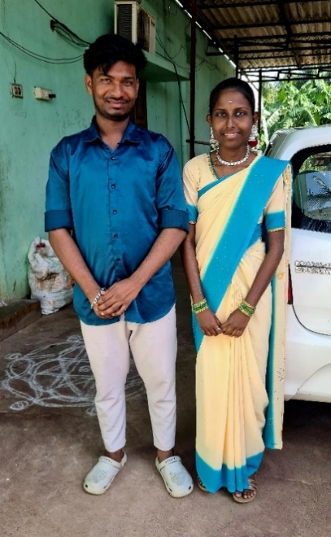Another former pupil, Rajeshwari, will be well known to many of you who read our newsletters or follow us on Facebook. Friends of Mettupalayam have supported Rajeshwari, who is profoundly deaf, and her family for many years, as both parents also have a disability, mother Rada is profoundly deaf from birth, whilst father Elumalai is almost blind, due to not having been provided with goggles whilst he was working as a welder. Rajeshwari first came to our primary school as a 4 year-old, and thanks to a UK contact, she was admitted to the Sylvia Wright School for the Hearing Impaired. Rajeshwari completed her education right up to higher secondary level, and was then accepted into the Presidents College in Chennai, one of Tamil Nadu’s premier universities. She will complete her studies in the summer. It is exciting that last month, family arrangements were made for Rajeshwari and Santos, who were in the same class at school, to be married later this year.

Over the years, Venkat has made many contributions to support pupils either in secondary school or college. It may have only be a small sum to pay for essential expenses, like joining the school pta, buying extra books or items of uniform, right up to paying college fees for the year. For many, this has enabled them to continue in education.

The last newsletter included information regarding the planned installation of solar panels. It is exciting to be able to confirm that the donor, Glen and his wife visited the project this week and were able to provide their expertise and meet with the solar installer at the project. By the time this letter is sent out, the panels should have been installed and be in use! Projected savings indicate a return of capital within 4/5 years, and an annual saving of around £450, together with the environmental benefits.

Farm work continues and a reasonable monsoon season should ensure good crops later in the year. Expansion of the orchard land continues, with a further 10 acres due to be planted this year bringing the total to around 23 acres. This will mostly be fruit trees, but some teak wood trees are also planned. The oil pressing machinery is working well although Venkat is looking to perhaps employ a further worker to expand production once the harvest resumes. Cattle have always been kept on the farm, ever since Bedale Primary School donated the money to buy the first cow, obviously named Bedale! The entire herd was recently sold, apart from a granddaughter of Bedale and there are now two calves, with another hopefully coming later in the year.

It is amazing that Venkat has now been working in Mettupalayam for over 40 years, firstly with a very small group of village children, with little funding, in 1984, to starting evening classes for the Kuruvi tribal children around 1990 and now teaching a 3rd generation! Friends of Mettupalayam have been supporting his work now for around 35 years, and our thanks go to all those very committed and loyal donors who help us find the funds to continue this very important work.

Finally, thanks to Venkat, the schoolteachers and all the villagers for being so welcoming and friendly to visitors. It is a real privilege to be able to visit and experience a little of their lives, hopes and dreams for the future.

Contact us:

Adele Eldridge Francis and Rosie Muncaster Hugo and Jean Welsh

01969 650618 07491948878 07802641073

adeleeldridge@gmail.com fmuncaster@hotmail.com hugo.welsh30@gmail.com