

November 2024

Dear Friends,

As we approach the end of another eventful year, we are pleased to update you on things at Mettupalayam and to give a progress report on some items from our August newsletter.

**The Crakehall School in Mettupalayam**

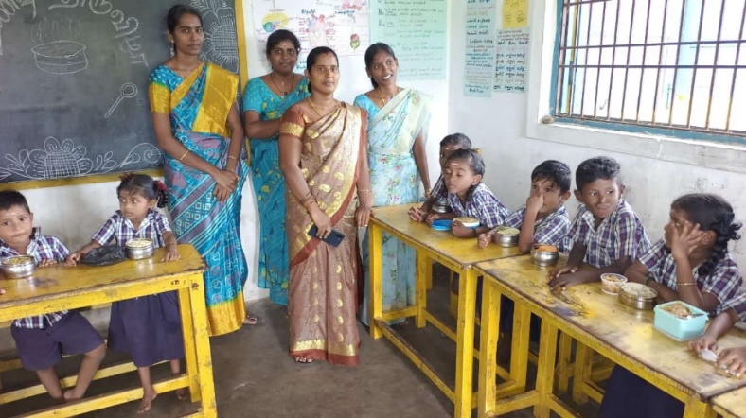School numbers and attendance levels remain strong, and Venkat is pleased with the progress of his relatively new teaching team. We have two FOM Trustees who have teaching backgrounds, and they plan to strike up a regular online connection with the Mettupalayam teachers. The idea is at a formative stage and there will be logistical and language issues to be addressed, but it is hoped that the link can provide shared learning, foster an increased level of belonging and demonstrate the value we place in the key role the teachers play in giving the local children the best possible start.

**Post-Primary school support**

As reported before, Venkat has been highly successful in attracting children from the local gypsy village to our primary school. While the Mettupalayam village children now all progress into secondary education when they leave our school, this is much less the case with the gypsy children. Venkat tells us that there are some thirty children (mainly girls) between the age of 11 and 17, who regularly wander aimlessly around the area, with negative outcomes such as poor health, unwanted pregnancies and lack of any educational progression.

Consequently, Venkat has asked us if we would support the setting up of a “club” for this group, to provide support such as vocational/crafts training and health education. We have told him we are very supportive in principle and asked that he put together a more detailed proposal. Until such time as the local authorities enforce further education attendance, we feel we should do what we can to ensure that the education we provide at primary school is not wasted on this marginalised group.

We are so lucky to have someone in Venkat who has such a complete understanding and appreciation of the needs of all groups in the area around the project.

**Two Capital Expenditure Projects**

**Solar Panels** – Following the appeal for support in our last newsletter, we were thrilled to be contacted by Glen Peters, a friend of FOM, who runs a solar panel business based in Pembrokeshire. Glen has offered to pay for the full cost of the installation in Mettupalayam. He is also planning to visit the project in February and Venkat is arranging for the local installers to be present for his visit, after which we will give the go-ahead. Thank you very much, Glen.

**Deep Bore-well** – It is planned to go forward with this in the first half of 2025, which will be the appropriate time for the work to be done.

**UK News**

We are pleased to say that Francis is going to visit the project again in January. This time he will be accompanied for part of his visit by his son Daniel and Daniel’s daughter Ella. The visit will serve many positive uses. Firstly, it is a great fillip for Venkat. Secondly, Francis will be able to provide a fresh eye on all the work the project is doing. And thirdly, it will be lovely to have two new visitors in Daniel and Ella to show our continued support for the team.

Venkat keeps the schoolchildren informed about Friends of Mettupalayam and finds ways to celebrate the links with us here in the UK. Here, the children are singing happy birthday to our co-founder Adele. And there is the bonus for them of course, a slice of very sweet cake!

**Fundraising**

We had a fantastic set of donations via the wedding of Cody Sands and her husband Sarvesh. Cody is the granddaughter of our great supporters, Susan and Martin Sands. Sarvesh is originally from India and Cody has always had a keen interest in the project though her parents and grandparents. When they got married recently, they asked that donations be made to FOM rather than receiving wedding gifts. What a wonderful thing. We received over £2000 in donations through a JustGiving account we set up for them. Here they are with Cody’s proud grandparents.

As we approach Christmas, two of our trustees are planning coffee mornings for neighbours. It is an opportunity to spread the word and raise funds. If anyone wishes to do the same there is lots of information available about the project on our website at irdt.co.uk

We hope you have found this update useful. Please do let us know if there is any subject you would like us to cover in future editions.

Venkat and his team send their very best wishes to you and your families for a very Happy Christmas and New Year.

Contact us:

Adele Eldridge Francis and Rosie Muncaster Hugo and Jean Welsh

01969 650618 07491948878 07802641073

adeleeldridge@gmail.com fmuncaster@hotmail.com hugo.welsh30@gmail.com