

August 2024

Dear Friends,

*“****Caring and Sharing****, that is what our project is all about Hugo”.* Venkat has a way of getting to the heart of things, using words that have a certain power. On our phone call he had just told me how he had arranged for a small supply of rice, biscuits and clothes to be collected and distributed following the catastrophic mudslides that have killed hundreds of people and made countless more homeless in the neighbouring district of Kerala. Sometimes your support does not just help the people in Mettupalayam and its surrounds. Which reminds me of that marvellous quote that David Eldridge elicited from the then Bishop of Durham “Charity starts at home, but it doesn’t have to stop there!”

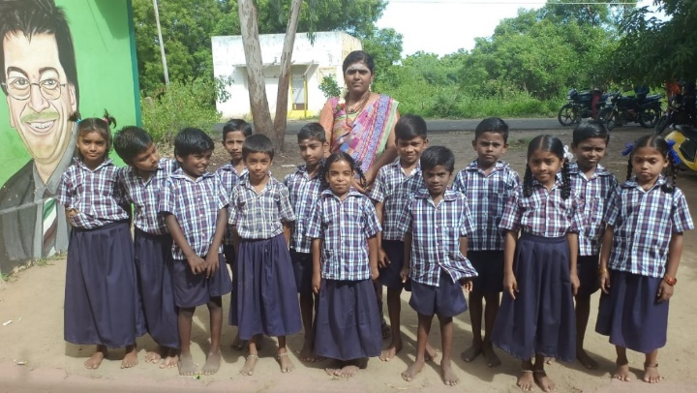**The Crakehall School in Mettupalayam**

Venkat is very happy with his relatively new team of six teachers which includes two former pupils who have gone on to gain their teacher training qualifications and one returning teacher Mohana, who had been a valued member of the team before leaving to have a family. According to Venkat, school numbers are at 85, but sometimes increase to 95 when he can encourage a reticent group from the gypsy village! As previously explained, some of the pupils come from difficult beginnings and require extra help. This year, this includes two children who cannot yet speak. All the pupils have been issued with new uniforms and the school team provide breakfast for around 25 children. Recently breakfast has also been given to a small group of local old-age people who are living on their own and with little support. This is in addition to the school and old age people mid-day meals programme.

**Healthcare and Education**

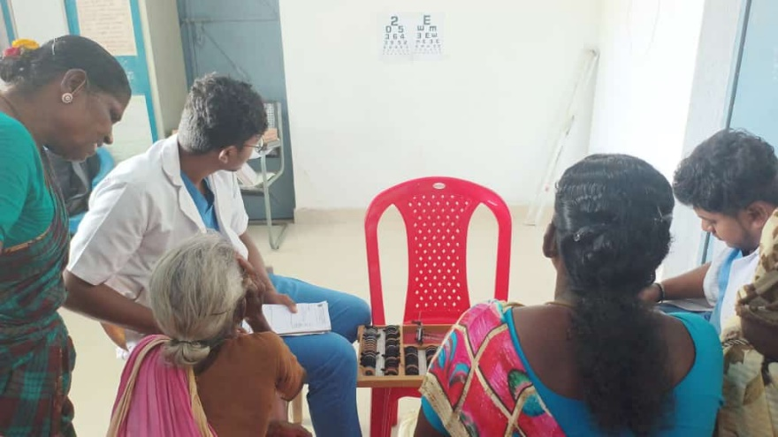The project is increasingly using local medical colleges to provide health camps for education, check-ups and treatment. The colleges are required to provide free support to rural areas and the only cost to the project is in the provision of food and drink during their visits. A particular focus has been on eye health for older people and dental health and education for children. This has included educational sessions in school and Venkat has arranged for new toothbrushes and the supply of toothpaste for all 95 pupils

**Farm**

Fortunately, the severe monsoons in Kerala have not hit Tamil Nadu, but there has been sufficient rain to allow the preparation of fields for planting of paddy and pulses. Venkat has also planted 250 coconut plants. He says they may take 5 or 6 years to fruit but will then last 100 years – long-term planning!! (The photo shows some existing product on sale). However, the excavations of a very deep quarry right next to our farmland have meant that our existing borehole is now not drawing sufficient water for our wells. This is a major issue for the necessary irrigation of our fields. We hope to address this as part of two capital projects outlined later in this newsletter.

**UK News and Fundraising**

We recently enjoyed attending another coffee morning at the methodist chapel in Upper Poppleton, a regular annual event where all the funds raised are donated to our charity. The photo shows our sales table, carrying goods from India as well as locally produced items and donated items. The cake stall also went down very well!

Our Friend Karen continues to run regular jewelry workshops, kindly donating all the money raised to us, thanks Karen!

Our long-standing link (over 30 years) with Bedale Primary School continues, and Adele has been into school several times last term, sharing news and information with the children. A joint art project is proposed and donations from the school have paid for a lovely new supply of art materials for the children in Mettupalayam.

Finally, we are still very happy to come and give slideshow talks to any groups that would be keen to find out more about our community and friendship with the people in Mettupalayam and district.

**Two Capital Expenditure Projects**

We have been in discussion with Venkat about two new requests for funding.

First is the installation of solar panels on the roof of the project building. With the almost constant supply of sun, the ever-increasing cost of electricity supply, the potential to store a small amount of energy in the case of (quite frequent) power cuts and the availability of government grants, the Trustees believe that this is a sensible time to make this investment.

Second and as highlighted earlier, we have a need to address water supply for the farm and we would like to support Venkat’s request for a new deep borewell which he advises is vital if we are to reap the benefits of the farm.

Each of these projects will cost in the region of £2000, a total of £4000. We recognise that these capital projects are somewhat outside the normal project running costs and therefore would like to seek special donations specifically for this. If you or anyone you know is interested in supporting this or knowing more, please get in touch. Thank you.

Venkat sends you his sincere thanks for all your support, without which the project’s caring and sharing would not be possible.

Contact us:

Adele Eldridge Francis and Rosie Muncaster Hugo and Jean Welsh

01969 650618 07491948878 07802641073

adeleeldridge@gmail.com fmuncaster@hotmail.com hugo.welsh30@gmail.com