February 2024
Dear Friends,
Welcome to another update from your project. It is comforting to know that despite all the bad news around the world, your support allows Venkat and his team to work every day on improving the lives of the whole community around the project area in rural Tamil Nadu. Every time we speak with Venkat he has a story about this gypsy girl who is now attending school, or that village grandfather whose diabetes has been diagnosed and is now being treated, or those ex Crakehall primary pupils who are top of their class in the local high school. Your support changes the life opportunities of countless individuals.
The Crakehall School in Mettupalayam
Our project was founded around education. We have always been proud of the quality of teaching and the supportive learning environment at our school in Mettupalayam.
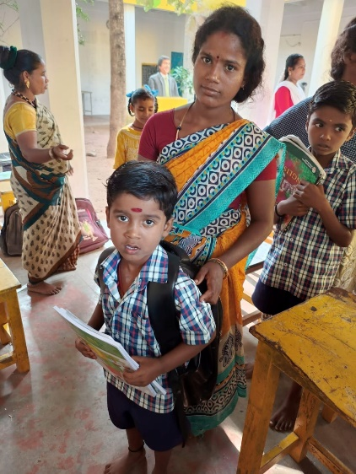
As we have reported before, pressure has been building on our ability to attract and retain good quality teachers, due to the availability of better paid work in the increasing number of factories which are now within commuting distance from the area. In January, your Trustees had a very useful and informative zoom meeting with Venkat to discuss this and as a result we have agreed an improvement to teacher salaries and a revised structure. This will develop a team of six teachers – two senior teachers, two established teachers and two junior level teachers – all with improved salaries. This will allow a teacher to pupil ratio of 1/15 (when all teachers are present) which acknowledges the extra needs of the majority gypsy children. Venkat is delighted with this plan. As a skilled teacher himself, he has always said that education is the heart of the project. As a Trustee team we recognise the extra pressure this will put on our budget, but also that it is the right thing to do.
Hot off the press, we can tell you that Venkat has already made changes, with the appointment of three new teachers. Geetha, Amuthavalli and Mary all commence at the end of February. Geetha and Amathuvalli are former students and all three have gone on to college and gained success at Teacher Training College.

Healthcare
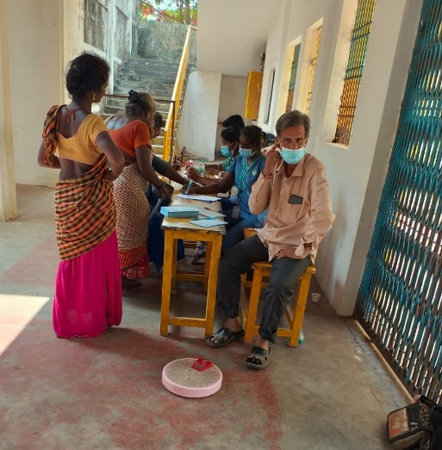
At present, a local doctor runs an afternoon clinic once a week at the project. This has been invaluable in the past in providing advice, medicine and in identifying the occasional major issue for further treatment. However, given the slow general improvement in local living standards, we are reviewing our current arrangements to see if the service can be streamlined and with an increased emphasis on health education. We will continue to update on this.
In the meantime, Venkat uses his extensive local contacts to provide extra medical support. Recently, this has involved a full day visit by four trainee doctors from a nearby college, who focused specifically on the nearby gypsy village. There are 350 people living here and suffice to say that they were a challenge for the trainees!
We have also had another Eye Camp for the whole local community, targeted mainly at identifying cataracts and then arranging for their treatment.
The Farm
Our farming land surrounding the project is another of Venkat’s passions. In addition to keeping close links with local farmers and the adjoining cooperative, his team has been busy planting – 100 coconut trees, rice paddy in 10 acres, and guava and mango trees across three acres of our land! All provide local employment and future income for the project.
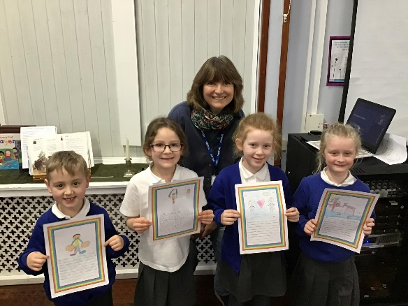
UK News
Trustees have held a coffee morning to spread the word and raise funds, with £170 raised by friends in Haxby and a further one to be held in Bedale in March. Our project co-founder Adele has spent many hours talking to classes at Bedale Primary school about life in Mettupalayam and sharing her experience. So, we were absolutely delighted to hear that the school had raised £300 in donations for FOM. At their request we have agreed that the money will go to buying art materials for the Mettupalayam school and Adele is now working on a joint art exhibition between the two schools – for a future newsletter!
The final instalment of “Venkat’s Story” is attached. We hope you have enjoyed reading this snapshot about our project leader’s eventful and inspirational journey. Re-reading it makes me quite emotional.
With all our very best wishes and thanks as always for your support.

Contact us:
Adele Eldridge Francis and Rosie Muncaster Hugo and Jean Welsh
01969 650618 01677 425961 07802641073
adeleeldridge@gmail.com fmuncaster@hotmail.com hugo.welsh30@gmail.com

Venkat’s Story….
- Venkat, who have been your inspirations?

In my life, the inspiration has been David Eldridge.
In history, I am inspired by leaders like George Washington, Abraham Lincoln, Winston Churchill, Mahatma Gandhi and Napoleon. They were mostly leaders born of poor families.

So now, my view was expanding from just the school to the entire community. I selected youths to send to Bangalore for training. One was trained as a mechanic and now has his own company. Three girls were sent to APD disability training in Bangalore for 6-months. They then supported around 300 disabled people across the Mettupalayam area and as far as Nambikki. In 2004 the Tsunami struck the coast. At 8am in the morning people saw the sea retreating and they went in to catch fish, but then they saw the huge waves which then washed over half a mile from the seashore inland. It was a Sunday and we heard about it on the same day. The very next day, we took a van with medicines, clothes, food and some money. I talked with FOM and they agreed to spend project money. I stayed in the area for five days initially with the ambulance van and took people to Chengalput hospital. We supported up to six villages in the area. We then chose thirty villages and selected one volunteer from each village. The key information we gleaned was that small children needed milk and so we provided four litres of milk plus biscuits and sugar for each child. We then arranged health check-up camps. We then saw that many areas did not have schools. In particular the fishing community children needed to walk several kilometres to any school. Therefore, we selected the village and dug a borewell for good water, constructed huts out of coconut leaves and started a school. The school was initially for fifteen to twenty pupils. Some had never been to school before. After that all the local families started to send their children to our school so we wrote to David and Adele and they came to inspect the area and we got a large amount of money from the FOM campaign which enabled us to build the school and buy the land. So, we made it an English medium school and eventually it had 130 children. We took the opportunity to take children from Mettupalayam to visit and vice versa. We also provided a disability centre in Nambikki with tricycle wheelchairs bought from APD in Bangalore and distributed hearing aids. During this time after the tsunami, many people had trauma and PTSD. I decided to ask for money to buy a television to take people’s minds off the trauma. It was a strange approach, but it worked! People had lost everything when the tide smashed huge buildings and schools down. It was lucky that the tsunami happened on a Sunday otherwise more people and children would have been drowned. Chris and Ali Riding came to the project at that time too.

- Venkat, what are you most proud of?

Well, a number of things. 1st, my work in Andhra Pradesh in 1976. I will never forget the people there who I was able to help by providing food medicines and clothes. Solving some of their problems made me feel very happy. 2nd, the work we did with the poor people with the strike when the poor people won the battle with the rich landowners. 3rd when the Mettupalayam area reached 100% literacy after 10 years of hard work. This was measured by the Indian government and not only on the ability to read and write but also people knowing about their rights through the government. 4th, learning from all our UK friends about honesty, sharing and caring. For the first time local people realised that foreigners were here to help and not to take. 5th, making sure that all children got midday meals. I was so happy to see this and providing food for over two hundred and fifty old-age people in four local villages. 6th, implementing a disability programme. One of many examples that stays with me is of a 20-year old girl with no leg movement. We constructed a toilet specially for her and a wheelchair. The changes to her life were incredible to see.
In 1996 I visited The UK and Richmond and David and Adele took me to Wales to visit a friend of theirs called Sian. She lived in a wooden house, a round house. I stayed in a tent In minus 3 degrees there was two inches of snow on the ground! Sian arranged a meeting with friends who included Susan Sands. Susan said “I was born in India I love India”. So, I said please come to Mettupalayam. In 1997 I got a message from David saying “Susan and Martin are coming to visit - take care of them!” They have been coming every year, ever since then.

Venkat is delighted to share this story with friends. He says we may be getting older, but the project is still young!

