December 2023
Dear all,
Many of our Friends will know that I have just returned from visiting the project, as I have been posting information on our Facebook page “Friends of Mettupalayam”. Unusually, this is my second visit this year, and I feel so blessed to be able to spend time with Venkat, the staff and the wonderful children at our Crakehall Primary School. They all really look forward to visitors and make them so welcome. Highlights of my visit were, a school outing, a food festival organized for the children, and of course, just experiencing something of the lives and hopes and dreams of the next generation.
Crakehall Primary School.
As highlighted in previous newsletters, our teaching staff changes frequently, but this has been exacerbated of late by the significant rise in living costs, and the wages available at nearby large manufacturing businesses. We are currently short of two teachers, and this means that Venkat is having to spend more time in school, teaching mainly year 5 pupils. We are now considering our budget for next year, and a significant rise in teachers’ wages is on the cards.
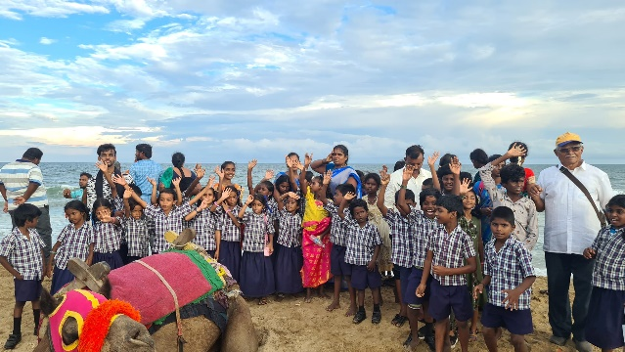
As usual, a school visit was arranged, and this time, we hired two coaches and 49 children and staff set off for the zoo near Chennai. As well as children from the top 3 year groups, we also arranged to take some children from the Kavakarai tribal settlement near Manampathy. After a picnic breakfast in the zoo car park, a very enjoyable few hours was spent walking around the animal enclosures, before setting off again for Mamallapuram, a town famous for its outstanding beautifully carved sea temples. Some of the children had never seen the sea, and many enjoyed paddling in the surf, carefully attended by Venkat, as the waves were quite strong. On the return to the coaches, the children all spent their pocket money on sweets, fruits and souvenirs from the many vendors along the path.
Earlier I mentioned a food festival. Venkat spent some time with the top two classes talking about the different foods available, and what their favourites might be. He then asked the children to prepare a dish and bring it to school after the weekend. Teachers were also invited to take part, and so, on Tuesday, 30 children and 4 teachers brought in their offerings. To say the dishes were varied would be an understatement! Mostly vegetarian, except for the Kuruvi children, who brought in dishes containing bird meat, squirrel meat, chicken and prawns!
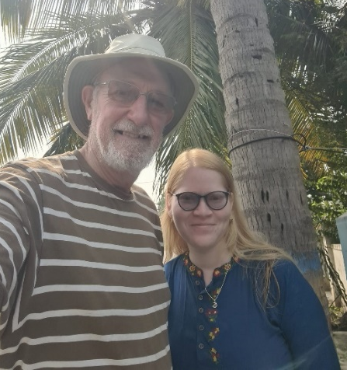
Prizes were awarded for the best 3 dishes, and the overall winner was Devaraj with a prawn curry that looked delicious. The teachers’ offerings were also amazing, evidence of the effort that they all made.
The prizes were new tiffin tins, and all the entrants received new metal tumblers, with everyone receiving Quality Street chocolates that I brought especially from home (another tradition!). There is a video on Facebook which I highly recommend.
It is always exciting to catch up with former pupils and this time I was delighted to visit Sonhiya, who came to our school as a very shy child, very aware of her difference. Rosie and I would bring sunblock each time we visited. After finishing higher secondary school, Sonhiya is now in her second year at college, studying to be a lawyer, specializing in women’s issues. She is a prime example of the benefits of a good, inclusive education that Venkat tries to provide for all the children.

Farm

So far, this year’s monsoon has been disappointing, with only around 50% of the usual rainfall. This will affect which crops are planted, so focus will be on more dry season crops, such as pulses and groundnuts, with only 4 acres of paddy planted, enough for our school meals programme. However, the senior children have been involved in planting various seeds in the school vegetable garden, a plot of around 0.2 acres adjacent to the school. They will be able to watch these plants grow, water them when necessary, and in 3 to 4 months’ time, start to harvest and then enjoy the produce in their mid-day meals! Venkat has also been busy with the children, planting hundreds of fruit trees, mainly guava and mango, to increase the farm’s orchard area to some 6 acres. This will also improve the environment and reduce the workload on the farm.
Another very successful diversification has been the oil processing unit. Investment in specialized machinery for dehusking peanuts, and for processing various seeds, is now starting to pay dividends, with increasing sales of the oil and cattle cake residue. Consideration will be given to expanding the workforce later in the farming year if this demand continues.

Social work

True rural development comes mainly through education, but Venkat also looks to help anyone in need in his community. Through provision of the weekly doctor’s surgery, through helping illiterate folk obtain their identity cards, and therefore their entitlement to pensions and ration cards, through arranging free dental health and eye checkup camps, the list is endless. His place in society is well established and very much appreciated, and he is often approached for his assistance, which is, of course, willingly given. Needs change over time, and Venkat is adroit at adapting and focusing on what truly matters.

UK News

Fundraising continues to be important to support Venkat’s work, and trustees are planning coffee and cake days sometime in the New Year- further information of the dates will be given through Facebook etc. Should anyone else wish to do a similar event, there are photos and information available on Facebook and our website, and I am always willing to assist in planning. I have also been able to bring back a few lovely stone carvings and handmade tribal bead necklaces and please do contact me if you are looking for unusual gifts for xmas. Meantime, thanks as always to our very generous supporters, many of whom donate monthly- your support and encouragement is vital and much appreciated both here and in Mettupalayam.

Finally, we wish you all a wonderful Christmas and a very Happy New Year.
Contact us:
Adele Eldridge Francis and Rosie Muncaster Hugo and Jean Welsh
01969 650618 07491948878 07802641073
adeleeldridge@gmail.com fmuncaster@hotmail.com hugo.welsh30@gmail.com

