August 2023
Dear Friends,
Our last newsletter was dedicated to Francis’ visit to the project in January, the first visit since the pandemic. At the end of this edition, we return to Venkat’s life story at the time he first encounters Mettupalayam and subsequently the birth of our project.
It is fascinating to think back to that time. Here is one quote from Venkat’s story. “In 1984, on August 15^{th,} Independence Day, I raised a flag and started a school with just me and one other teacher.” We can now take stock of the incredible progress in education, health, social inclusion, the roles and standing of women – and so much more - that your support has allowed Venkat and his team to achieve. And as you will hear, he is never satisfied, there is always more to do and somehow, he has the energy to make it happen.
How are things at the project?
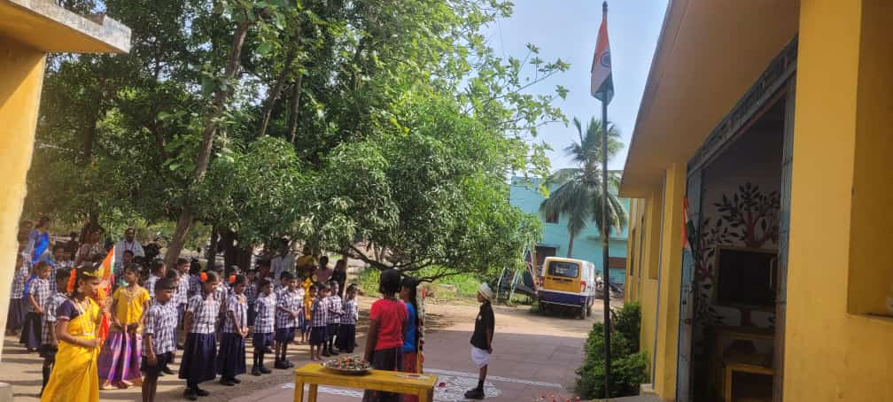
We are pleased to report that the amazing work you fund continues to deliver real change for the people of Mettupalayam and the surrounding villages. The primary school has 90 children on the register, with over 70 regularly attending. Here the children are celebrating Indian Independence day (quite a different setting to the one back in 1984, when Venkat taught outside sitting on a stone!) Attendance and timeliness have been improved by the recent provision of a free bus service which passes the local gypsy village. We have had a significant turnover of teaching staff, but now again have a full team of 6 plus one other, who plans and manages administration and accounting.
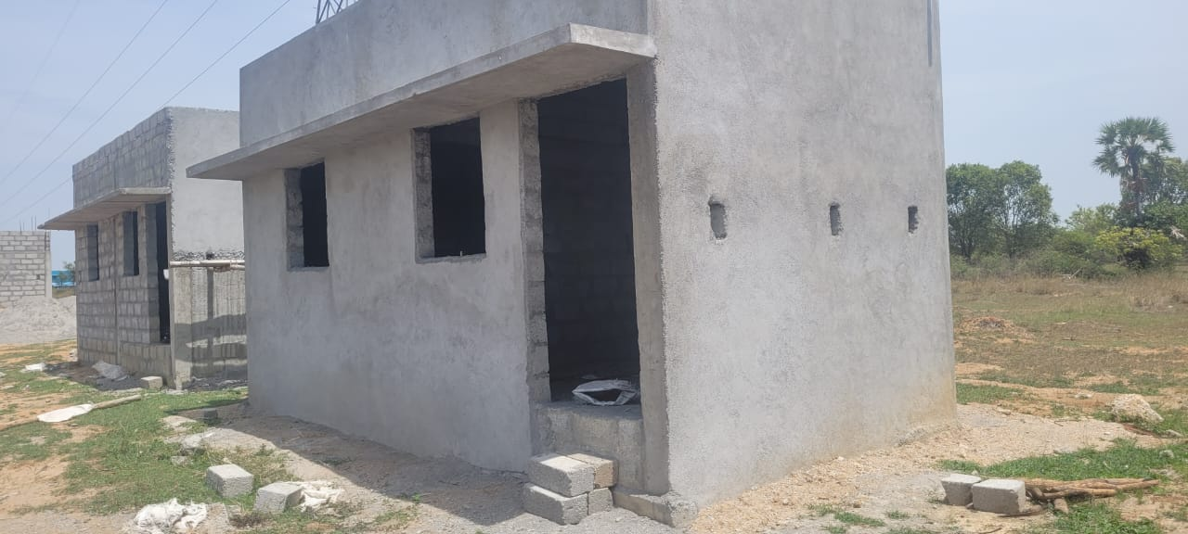
In the last newsletter we told you about the houses being built by the government for the quarry tribal group who currently live in mud huts not far from Mettupalayam. We are pleased to report that the basic dwellings will soon be ready to be lived in. This will allow 15 families to move to safe and dry accommodation, in-built toilets and clean drinking water from a borehole that has already been dug. The houses are also on the new bus route, which will support travel and work options. We understand that the new houses do not include 4 or 5 families who because of their itinerant nature were not included in the government plans. His work is never quite done!...
…And Venkat is now proposing a new programme targeted mainly (but not exclusively) at young girls aged between 10 and 17 yrs, focusing on education, wellbeing, and social support. Initially this would focus on local gypsy, tribal and hunter communities where the drop-out rate from secondary education is very high. The initiative appears to fit well with issues arising across India. We will be discussing the proposals, their implications and funding needs with Venkat and look forward to updating you on this as soon as details and ideas become clear.

UK News
Thank you all for your invaluable continued support – whether through your regular donation, holding coffee mornings or just by helping to spread the word. If you have any questions please don’t hesitate to get in touch with one of us, or check out our website at www.irdt.co.uk for ideas and information.
Attached is the next instalment of Venkat’s life story, this time as he first comes to Mettupalayam.
Venkat and his team send their thanks and warmest wishes.

Venkat’s story, part 4
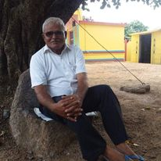
In 1981, I was working for a charity called Service Civil International. I came to the area of Mettupalayam and surveyed thirty villages. I found that six hamlets had no school and the worst poverty. It was then that I thought to myself this is the time and this is the place for me. I had friends in other relief organizations such as Action Aid and Oxfam. I stayed in the area for 6 months and did evening schools for youths and a day class in Mettupalayam. I stayed under a Tamarind tree for one month and then the locals gave me a small hut. I had just twelve children coming to my class. In 1984, on August 15^{th,} Independence Day, I raised a flag and started a school with just me and one other teacher. I applied for financial aid from all the charities and got the best response from Action Aid. The first instalment was for 3750 rupees (c £37). I then registered with the Government, but they needed it to be more than just a one-person school. I had to form a Trust and on 17 February 1986 I formed the Indian Rural Development Trust, IRDT. After this there was me, my wife and one friend teaching the children. We now had sixty-eight children, from Mettupalayam and local villages. In 1988 we moved to where the old-school area was. We constructed two huts, applied to Action Aid and they gave 40,000 rupees to construct the old school building. After that we had one hundred pupils and got a further 12000 rupees to construct the extra building. The numbers grew to one hundred and sixty children. In 1993 Action Aid phased out their policy and changed their focus to support larger projects. They gave me 50,000 rupees as a final payment, and I leased three acres of land to grow vegetables.
David Eldridge came to Bangalore in 1989 and was very upset when he saw small projects not getting support. Nagarajan was the field officer in Action Aid and met David. They came to Chennai and sent a telegram to ask to meet at Chennai Christian College. I met them there for breakfast. We then travelled to Chengalpattu and David asked us to stop by the lake. He said it looked like Ambleside. It was then that I spoke to David for the first time. He could not say my name and so called me Venka. It was the first time my name had been shortened from Venkatachalam. We came to Mettupalayam at Pongal time. David provided a further 15000 rupees to construct a building and to build and dig a well for water.
After David had gone back to England, he finished his studies at Teaching College he started raising money to send to IRDT. David met Francis at the bank where Francis worked. David and Adele then came back to Mettupalayam in December 1992. They spent 6 months teaching at our school and stayed in the Ashram before moving to our teacher Chitra’s house in nearby Manampathy. A charity called “Child Relief and You” gave us support and we gave them a budget proposal. They sent 1.5 lakh rupees every year for 3 years. David raised money through the charity he had set up in England called Friends of Mettupalayam (FOM) from about 1995 and in 1996 David asked me to visit England for the first time.
In their teaching in Mettupalayam, David and Adele used many materials and took the children on trips, for example to Verdantangle bird reserve where they would walk with the children and talk with them about about birds. Adele worked with the younger children creating syllables and many things. David worked with standards 3 4 and 5. This gave me the chance to focus on rural development in the area.
One day in school we heard crying and there was a child who was barely alive but, the priest had said not to take to hospital even though it was dying. I took the child to Chengalput Hospital where he was put on a drip for 12 hours and eventually started to move and cry. This sparked my focus on rural development and about all the local superstitions. For example, one TB patient was taken to the priest who told him not to be moved for 4 days. I said no, we must take him to the hospital. The people would not listen, and the man died. After this, people listened to my advice and then seven patients came with me to hospital and 5 people eventually recovered by following the hospital instructions. The two people who did not follow the instructions died.
In 1993 we started providing a lunch program for the children after David realised that he and Adele were eating lunch, but the children were not. David and Adele asked how much money we would need to give lunch to them all. I said just one rupee for two children. David sent a letter to his friends asking for more money. Since then, we have never stopped providing food at lunch for the children. In 1997 David and Adele discovered that there were thirty old age people in Mettupalayam village who only had enough money for one meal a day. Then they asked how much it would cost per person to provide another meal. I told them it would only cost 1.5 rupees per person and that 100 rupees would feed them all, every day. When David saw the old people receiving food, I had never seen anyone so happy. Still, we are doing it where it is needed.

