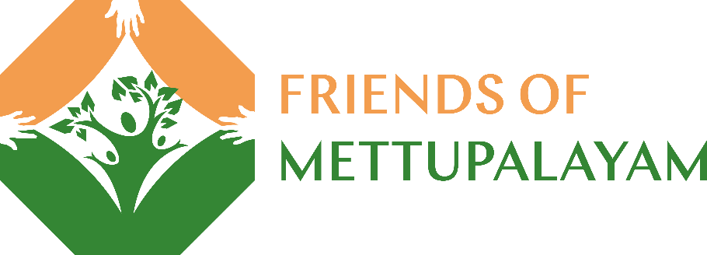
February 2023
Dear Friends
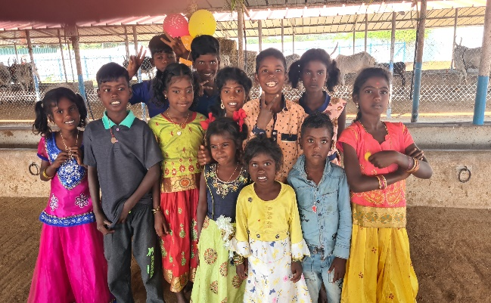
It has been three years since anyone from the UK was able to visit Mettupalayam, so my trip in January was very special, in many ways. We have, of course, been able to keep in touch during this time, and Venkat’s work has continued, albeit much affected by the pandemic, and during the last year, by a financial crisis. In common with many charities in India, Venkat wasn’t able to renew his FCRA certificate that enables IRDT to receive foreign donations. So, he has had to fund the project from the reserves that he had set aside for just such an emergency. Whilst he has been waiting for some time, I understand that the delay is now being addressed. Meantime, expenditure on capital projects, farm inputs and even Venkat’s salary, have been postponed! The timing of my visit couldn’t have been better, as I was able to alleviate some of the financial difficulties whilst there and facilitate an alternative means of getting UK funding to the project pending receipt of the certificate. We are now happy that funding will shortly be in place for the next year.
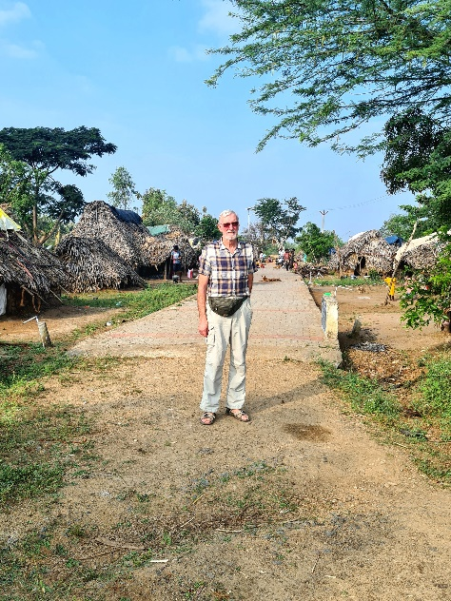
Despite these difficulties, Venkat has been able to continue supporting the local community, through our primary schools, nutrition programme, access to healthcare and in all the other areas that he has been working in for the last 35+ years. Whilst at the project, I was delighted to learn that at last, the Irula tribal group living at Ullampakkam, former debt slaves that we helped to freedom over 20 years ago, have now been officially granted 22 housing plots near the Patchyamman temple. Government funding of around £4500 per house has also been allocated and we hope that contractors will be appointed shortly. This will be a major improvement to their lives, as they will no longer have to live in palm leaf roofed mud huts which are prone to severe flooding in the monsoon season. Being nearer to Mettupalayam, we also hope that their children will be able to attend our Crakehall Primary School. I was delighted to meet again with some of these folk during my visit, and to renew our friendship.

Facebook followers of our charity will have seen the pictures of the damage to our school playground during the recent cyclone, which brought down many of the teak trees planted by Venkat around 20 years ago. I am pleased to report that this damage has been repaired, the fallen trees have been removed, and the swings, roundabout, slide etc. are now back in full use! Travelling around the area, it is obvious that few schoolchildren have access to facilities like these.
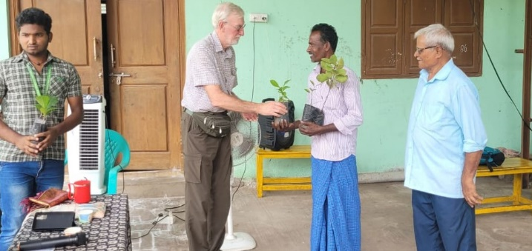
Although I mentioned that the farm work has been impacted by lack of funds, and much of our 35 acres had remained moribund, Venkat is working with a local agricultural college and is currently hosting 10 senior students. They have been overseeing a new method of planting rice paddy, which should increase yields and therefore, profitability. Some 6 acres of paddy have now been planted and Venkat is also planning an increased acreage of groundnuts (peanuts). These will be processed though our oil mill, generating income from the oil and cattle cake sales. Also working in conjunction with the regional agricultural office, I was delighted to be involved in handing out many improved varieties of fruit trees to members of the local farmers coop. Venkat also plans to enlarge our own orchard area, and the fruit trees planted some years ago should soon be yielding significant crops.
We are often asked how much support Venkat receives from local people. The first photograph on the newsletter is of some of the tribal children who live around Mettupalayam. Venkat was very pleased to be asked to select 70 children to receive a set of new clothes each as a Pongal gift. With the donor, we had a trip to clothes shops in Uthiramerur to select suitable wear, spending around £600, then took some of the children to receive their clothes during a very memorable ceremony. Pongal is a very significant time for Tamils, giving thanks for the harvest and celebrating the cow, a much-revered animal for Hindus.
Another very memorable day involved a school trip. The children were asked where they would like to visit- the seaside, zoo, bird sanctuary being mentioned. No, they wanted to visit the Golden Temple at Vellore. So, we hired a bus and the schoolteachers, around 25 of the older children and Venkat and I set off for a long day. Firstly, we called in to a beautiful hilltop temple at Ratnagiri. This visit involved climbing around 150 steps up to the temple and as always, we received a very friendly welcome from the priests. After a picnic breakfast in the grounds, we then went on to the Sripuram Golden Temple. Every day, tens of thousands of pilgrims visit the temple where they can receive a free meal and of course, a blessing. This was the first time the children had been able to visit, and they were all very excited to join the crowds. Finally, we returned to Vellore to visit the 16thc fort. This was built around another 1400-year-old temple.
Venkat has asked me to pass on his thanks for all the support and encouragement that you provide. It really does enable him to make a significant lasting impact, improving the lives and prospects for many, many people in and around Mettupalayam. The trustees of FOM also add our thanks for supporting our fundraising through such difficult times.
Kindest regards
Francis Muncaster, Trustee Friends of Mettupalayam.

