November 2022

Dear friends,
We must start by telling you that Venkat is very proud that Britain now has a Hindu as it’s Prime Minister!

As we write, the area around the project has had more than a week of continuous heavy rain. As a result, there have been many deaths across Tamil Nadu and all schools including our own have been instructed to close temporarily. You may have seen the dreadful pictures of flooding in Pakistan and Bangladesh, but climate change is definitely impacting India too. Your help enables Venkat and his team to give direct support to the groups that are worst affected by the heavy rains – in particular the quarry community at Ullampakam, the tribal group at Manampathy and the gypsy settlement at Pudhunagar. The incessant rain has meant that many cannot cook and so the project has provided temporary food parcels to those most in need. Work undertaken in recent years on the ditches around Mettupalayam has meant that the village has not flooded and we hope that the worst of the rain may soon be over. The trustees will continue to focus on this and what other investments may be necessary for the future.

Attached at the end of this newsletter is a further extract from a discussion with Venkat about his life. It is a powerful reminder of his lifelong mission to help those in need and to fight for their rights; and a reminder of how lucky we are to have him leading our project.

Health
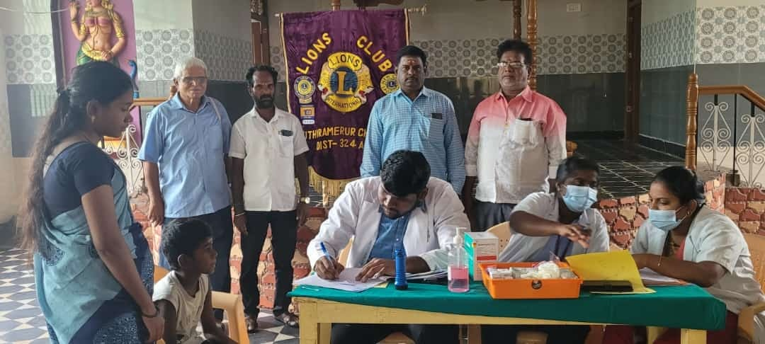
In conjunction with the local Lions Club, Venkat (who is their President this year) recently organised an eye check-up camp in the nearby village of Utherimirur. Over 150 people were seen, of which 20 were selected for cataract operations and 15 provided with new glasses. Blood pressure and blood sugar readings were taken and remedial appointments made.
Venkat has also organised another health camp in the village of Manampathi. This has had to be postponed due to the heavy rains but will take place as soon as possible. Manampathi is a small town about 4 kilometres from Mettupalayam and is where the project has been supporting an impoverished tribal group with education, food and shelter. Venkat has also been able to get government pensions for some of this group, a real life-saving benefit.

Farm
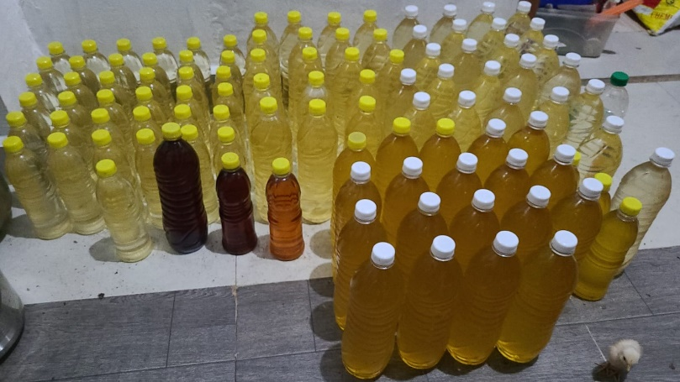
Venkat continues to invest in the farm. He has planted over 1500 assorted trees in recent years. These include teak trees and many fruit trees including coconut, guava, mango, lemon and orange. These will all increasingly bear fruit as they grow and mature. Fields provide crops such as millet and rice. He has also installed an oil making mill in our old farm building. One third of the cost of this was provided through a central government grant and the mill is now producing three types of oil – peanut, ginger and coconut. Venkat buys the raw materials from local farmers and then sells the finished products locally for a reasonable profit. Peanut oil is used for cooking; ginger oil is more costly and favoured for its flavour by the more well-off. Coconut oil is widely used as a balm by men and women and massaged into hair to keep cool!

School
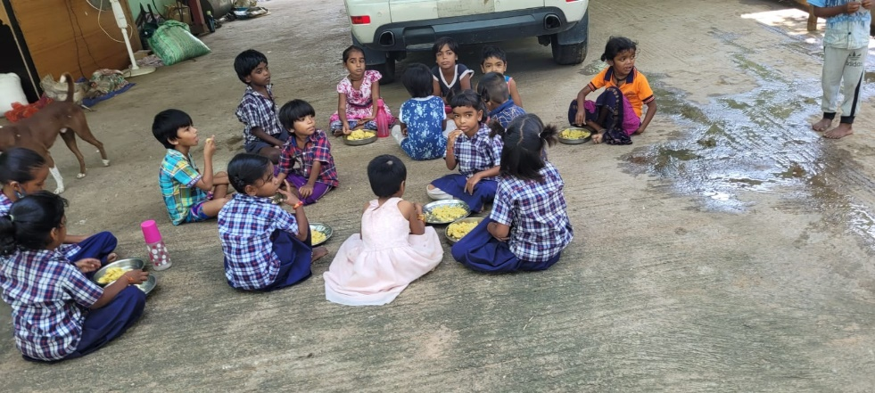
Other than the rain-enforced temporary closure, the Mettupalayam school is running well, with around 95 pupils across the six forms. Venkat is proud of the mix of village and gypsy students. This mixing at an early age avoids the caste discrimination often still prevalent in many parts of India. A pre-school breakfast is just way Venkat has attracted so many of the gypsy children and their families to attend schooling.

UK news and fundraising
There have been no visitors to the project since the start of the covid pandemic and the Indian government is presently making it much harder to obtain tourist visas. We hope that our new PM will enable an improvement in UK/India relations and that it will not be long before we can visit again.

Thanks to Trevor who is holding a flute concert in Crakehall and splitting the proceeds between the church and FOM and to the ladies at Get Together ( Carthorpe) who gave generously after Francis and Rosie's talk to them.
Please let us know if you have any fundraising ideas and remember, there are recipes and quiz questions you might want to use over the festive season on our website at https://irdt.co.uk/fundraising/

Thank you all for your support and we wish you a very merry Christmas and a happy new year.

Venkat’s story part three

The organisation I had worked for me to come back to an area in Tamil Nadu near Chennai in a town called Verdantangle. The initial Project was to support needy local people. We distributed food and supported pregnant mothers in and around 15 nearby villages and organised training, especially for the pregnant mothers. I found that many of the local farm workers were in bonded labour, working for five wealthy families. There were 2000 to 3000 people who were constantly in debt to the wealthy landowners and had been so for generations. I selected some local youths to help build roads with help from local government. For the first time, local people had found someone who was interested in them, but the rich landowners did not like it. I also encouraged the school age children to attend government schools. Eventually we reached 80% attendance level. Previously these youngsters were used as farm labourers by the owners. Through local investigation I discovered that each person was entitled to two acres of land for themselves. Also, the day after independence from Britain it was decreed that one person should not own more than 15 acres of land. The landowners had been transferring land to others in trust to avoid the law. The government was granting 2000 rupees to every person to develop their land, but the rich landowners were taking this for themselves. I took 35 local people with a petition to the Collector of Taxes at Kanchipuram, but unfortunately he was a friend of the landowner so just told him and did nothing. So, then I went to court and won the case that bonded labour should not have to pay loans back to the landowner. We then agreed a demonstration and a strike to complain about the abuses and people refused to work for the landowners. The local Collectors office then called a meeting of five of the rich landowners and five of the representatives of the workers, plus me. As a result, daily wages were increased by over 100% and it was agreed to discuss the issues of loans. It was a victory for the people and the local people built a special house for me. In that house I started to take classes for local youths and the local people provided food for me. I was aged 26 at this time. Landowners were known as Zamindars and they were used by the British during colonial times to collect taxes and to impose power over the people. Prior to British rule there were kings in India. There were three kings for the whole of Tamil Nadu. So now, the Indian government declared that the Zamindars give back land to the people. The Zamindars pretended that they had done this but, in reality they had not. When I took them on, the Zamindars put me under house arrest, but when the people found out they gathered together and forced the Zamindars to relent. I was fighting for the people’s freedom from the oppression of the Zamindars.
Around this time, I went to Sri Lanka at the request of people there who had heard about my work and struggles. I organised a fundraising event for the Tamil Tigers who were fighting for the rights of Tamils in Sri Lanka who had been discriminated against. Five of the Tamil Tigers came to the meeting, and we had 2000 people at the rally. Lots of Indian Tamils went to Sri Lanka during British rule to work on coffee plantations. After the British left, Sri Lanka did not want them, but 500,000 Tamils had settled in Sri Lanka. In 1981 I was advised to leave Sri Lanka due to impending violence. A friend of mine was arrested along with 50 co-workers and put into jail. He made a great speech but was killed. At the time, the Indian government was worried about supporting the Tamil Tigers wanting freedom as this might have meant that Tamil Nadu would want freedom too, so the Indian government started to support the Sri Lankan army. You may remember that Rajiv Gandhi was assassinated by a Tamil Tiger lady, near Kanchipuram.
Back at Verdantangle after the strike I lived and talked with the local people. Some said things were worse now because I had stirred things up. Some local lawyers then helped me to explain things and help the local people at low or zero cost. One example of this was of seven people who were given notice to pay up on loans or they would go to jail. There was a big court battle with the rich people’s lawyers. Three people were sent to jail for six months and four were freed. However, all expenses were to be paid by the rich people and so the rich people’s lawyer said ok, let them all go free. Also, all previous loan money’s where to become null and void. The rich people tried to get labour from elsewhere, but our local people persuaded them to go away and eventually the rich people tried to get people to pay loans for their own houses and again we defeated them on that too. Eventually we got one local per person of a low caste to become president of the local Panchiat (representing 2000 people). This was the first time the position had ever been held by a low caste per person. This was real power to the people. Then we organised over thirty women’s groups. In 1977 we initiated a government initiative to give free meals to the under 2-year-olds. Sixty women got government jobs to do this work.
The next phase of my life is when I visited Mettupalayam for the first time.

Contact us:
Adele Eldridge Francis and Rosie Muncaster Hugo and Jean Welsh
01969 650618 01677 425961 07802641073
adeldridge@gmail.com fmuncaster@hotmail.com hugo.welsh30@gmail.com

