July 2022

Dear friends,
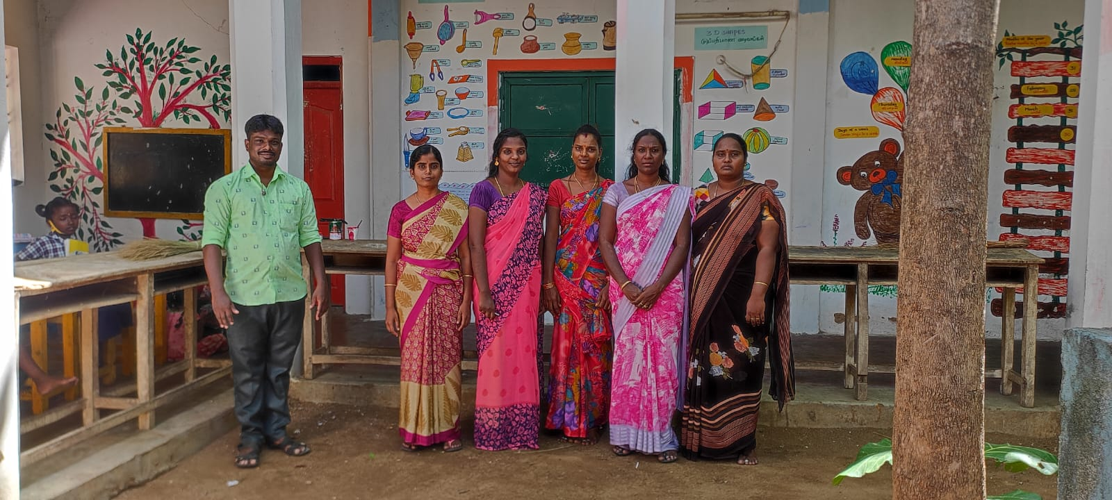
Here is a lovely photo of our teaching team at Mettupalayam, framed by the colourful murals around the school walls. This photo was taken during Venkat’s visit to us here in the UK. We were delighted that the project in India continued in all its facets despite Venkat’s 3-week absence, under the expert guidance of Venkat’s son Anand - a testament to the strength of the project Venkat has built with your help.

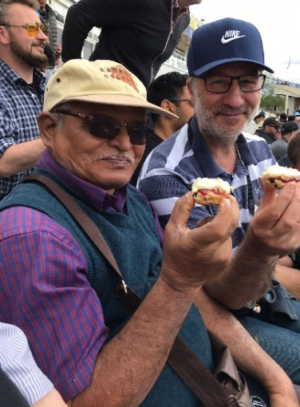
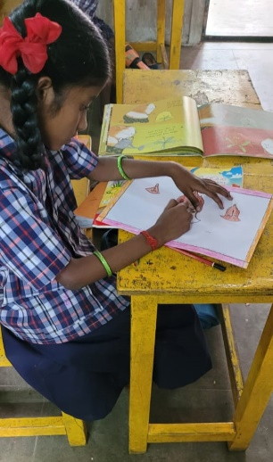
It was such a pleasure to have Venkat here. He spent a wonderful morning at the Pre-School in Crakehall, where as well as being delighted at the wonder of the children he reflected on the importance of the learning environment. ‘You see if you keep children in a square room, they will have square thoughts… I need to think about that…” He visited Crakehall and Bedale Primary Schools where information sessions with the children encouraged many interesting questions and deeper thinking about daily life, religion, plants, and global issues. The Global Awareness Club Bedale presented Venkat with a collection of letters for children in Mettupalayam. Pictured here is one of the Mettupalayam children already working on her reply. Letters will be waiting for Yorkshire children when they return from their summer holidays. Connecting the world!

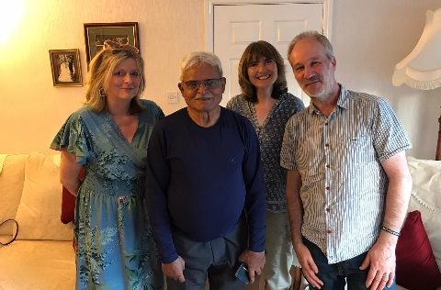
But it was also an opportunity to give Venkat some richly deserved down-time. He was able to reconnect personally with supporters and friends, some coming from as far as South Wales to see him. Friends took him to Edgbaston for the England v India test match (with scones!), hosted garden parties for him and took him on a day trip to Edinburgh.
Big thanks to Rosie and Francis for again being his hosts throughout his visit.

Venkat returned home safely and only a day later was seen sharing his photos and experiences with the children at the school – what unbelievable energy. All the costs involved, including air fares have been covered by Trustees.

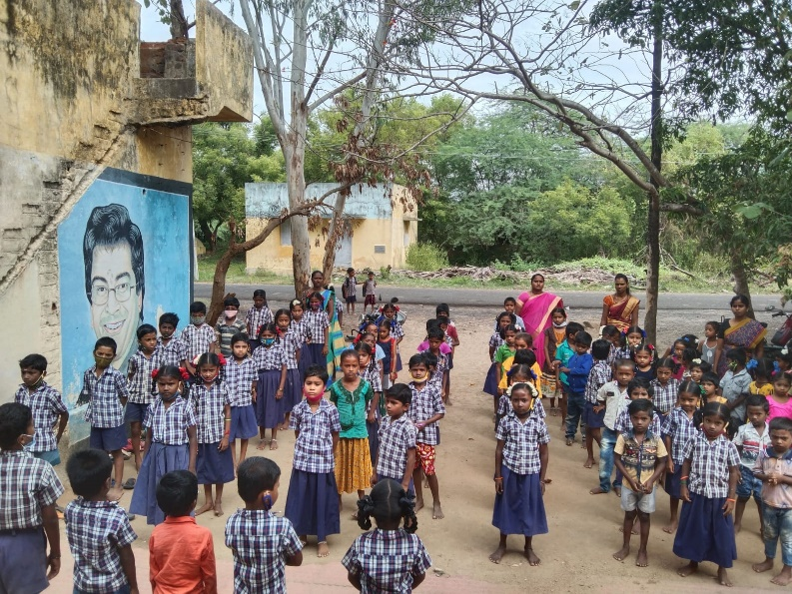
The Trustees had the opportunity of quality time with Venkat to discuss the future and his priorities for the project. Building on the comprehensive rural development structure in place, Venkat would like to find ways to encourage education beyond primary school for the local gypsy children and to provide increased healthcare and health education for all. He would also like to oversee a major programme of tree planting around the project area. More of which later.

School News
There has been a welcome and significant increase in pupil numbers at the Crakehall school in Mettupalayam. We now have around 100 on the register, up from 75 last year. This is mainly down to an increase in the number of children coming from the local gypsy village (who otherwise would probably have no schooling at all), very much encouraged by Venkat and the teachers starting a pre-school Breakfast Club where nutritious breakfasts are provided.

Other News
Venkat is a longstanding member of the local Lions club, and he has been honoured to be elected their president for the coming year. Like us, you might wonder where he is he going to get the time? But he has a cunning plan - to use them to deliver some of our priorities! Venkat has already talked with influential Lions members about how collectively, they can use their professional expertise to benefit the needy in the area. So, plans are being made for doctors and opticians to provide health camps, lawyers to give legal aid sessions, a rice mill owner to provide rice to poor tribal families and each Lions member to plant and adopt ten trees around the school and farm area – with the ambition to plant 1000 trees. In this way he will use the power of the team to drive real improvements in health and living standards across the area.

UK Fundraising

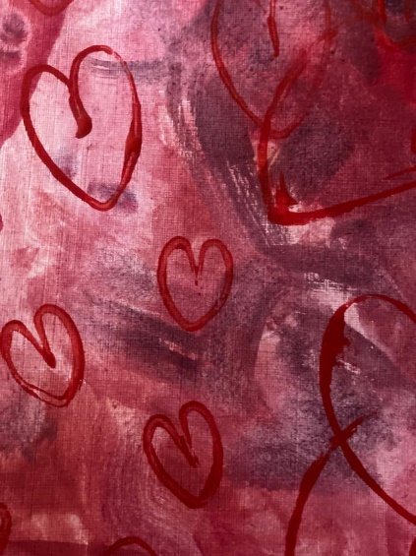
When the children at Crakehall school UK heard that it cost just £4 a day to run the Breakfast Club at Mettupalayam, they decided to do a sponsored march to see how many weeks they could fund. Despite the recent high temperatures, the children managed 15 laps of the sports field each. Thanks to you all for realising that you can do something and make a difference.

Rosie and Francis held an Open Day which was very well attended with friends old and new meeting Venkat, buying goods and supporting the project to the tune of £500. Fantastic.
So often a card can mean so much and we have had these quality cards printed, designed by some of our young school children to raise funds and share the love… Keep an eye out for them at fundraising events or contact Trustees for a pack of five for £5. It is hoped that different designs will be produced over time.

Following on from our last newsletter, here is another small instalment from a discussion with Venkat about his life.

Venkat’s story (part two)

- Why did you want to do service for your community?
In my college there was a social services league and we would do service for people over weekends. I would collect cleaning materials, writing materials and clothes and then give them to slum areas around my home village of Dharmapuri. Then, during a long drought period there was a camp using college students from all over Tamil Nadu and I was with 100 students digging a huge lake. Unfortunately, use of this Lake was monopolized by just one wealthy landowner and so we students started a youth Union. Then we heard that whilst poor people were being fined for cutting wood, a wealthy person was cutting down large lorryfuls, but not being fined! As a union we stopped this. During this time, I successfully completed my Bachelor of Arts in History. It was around 1980 that a major cyclone hit Tamil Nadu and Southern India. Over 4000 people died, and 250 villages were washed away. There were 20-ft high tides and we had to deal with bodies which were hanging high in palm trees. My college asked for volunteers to provide relief in the Andra Pradesh area. I travelled by train and then bus to the affected area and worked with up to 50 others in an area called Thumlaseeri. We took tents and installed them as homes and made toilets which we dug in trenches. There was no drinking water available, so we used a Jeep to collect water and distribute it. We then organised medicine for the school children and helped to hand out food supplies from charities. We arranged health camps to deal with diarrhoea and other common illnesses. I learnt the Telugu language to teach local children to read and write and to tell stories to primary level children. After about three or four months our relief work moved on to development work with construction and education. After between 12 to 18 months, things were almost back to working order. I stayed throughout this period before returning to my native area. When I left, many people came to the railway station saying, “please don’t leave Venka”. It was the first time I cried.

We hope you have enjoyed reading this newsletter. If you have any requests or ideas, please do get in touch.
Our thanks as always for your continued support, without which none of this would be possible.

Contact us:
Adele Eldridge Francis and Rosie Muncaster Hugo and Jean Welsh
01969 650618 01677 425961 07802641073
adeleeldridge@gmail.com fmuncaster@hotmail.com hugo.welsh30@gmail.com

