February 2022

Dear Friends,

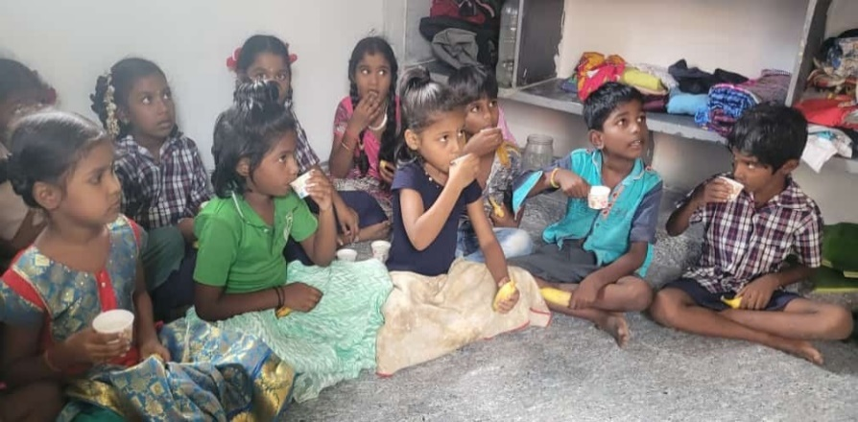
Welcome to our regular update from Mettupalayam. The last time we visited the project (way back pre-pandemic) we took time to talk with Venkat about his life’s work and the people and events that have shaped him. It was fascinating to hear his recollections and to realise how they had forged the qualities that have led to him devoting his life to improving the lives of so many in the area around Mettupalayam. It is quite a long story! so we have selected just a few reflections from Venkat on his early life to share with you at the end of the newsletter. If you find this useful, we can continue the story in future updates.

Covid 19
As you may have read, cases of the omicron variant have surged in India, as elsewhere and there have been numerous cases in the project area - including Venkat’s son Anand. Venkat too has had a bad cold and cough but insists it was not covid! We are pleased to say that both had been vaccinated and have not been too badly affected. We understand that 90% of local people have had 2 vaccines and a booster programme is being rolled out, but 10 months after the second jab. People must wear masks in towns even outside, at the threat of a 500 rupee fine, but according to Venkat if 100 rupees is quietly given to a policeman, he or she will turn a blind eye and give the offender a mask!

Health
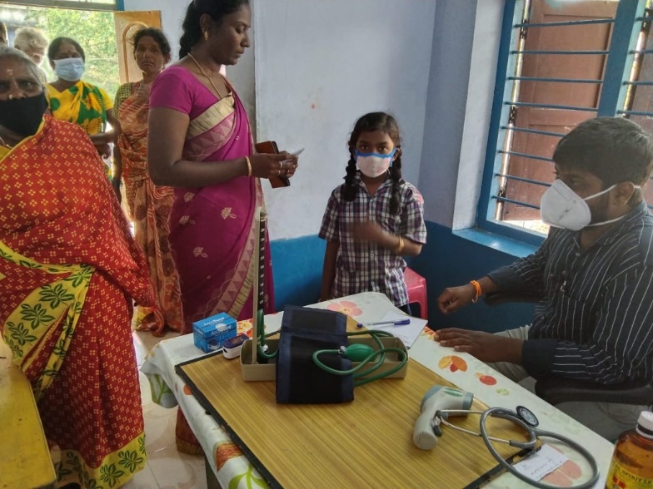
Our weekly health clinic has restarted with a new doctor, who works at a government hospital and can take patients there if needed. The clinic regularly picks up issues that need further treatment, but it also serves as a place for accurate information and positive health education. This is particularly necessary now with the level of misinformation that is just as prevalent in India, where “witch-doctors” still peddle home-made cures for every ailment. Health education is an area we feel we can provide an increased focus on in the coming year.
With government restrictions now eased, an eye clinic has been organised in coordination with the local Rotary club. Venkat is a longstanding member and we have had very good support over the years. Cataracts are a common condition from people spending long hours in the sun and patients will be taken for treatment to a hospital in Chennai. It is a life-changing operation.
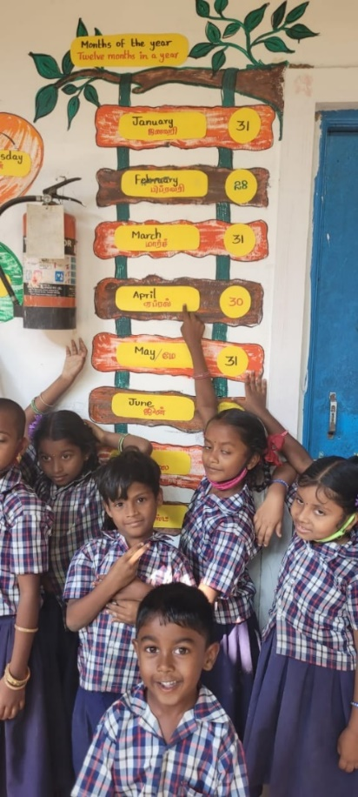
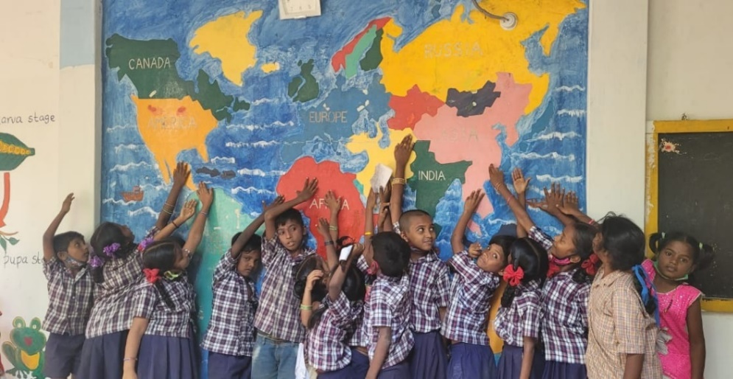

Schools
Venkat took the sensible decision to close the Crakehall school for a few days whilst Anand and one of the teachers tested positive for covid, but it is now back up and running. Despite this our pupils have been very fortunate that both schools have remained open throughout most of the last 18 months, whereas government schools were closed. We were very impressed to see these photos of murals on the Crakehall school walls, which were a joint exercise initiated by our teaching team – lovely.

The Weather
The extreme rains and flooding have ceased and now no rain is expected for the next 4 or 5 months! The proposed government help in re-housing our friends in Ullampakam (the quarry group) into proper concrete dwellings, has stalled. Apparently, now that the crisis has passed, officials are more focused on local elections, due in the next month. Venkat will try to apply what pressure he can on addressing this significant need.
At least the rains have meant that our wells are at good levels which has helped the supply to our paddy fields. Venkat is also very proud to have been awarded a national certificate as an Organic producer – where does he find the energy?!

Fundraising
As always it is truly wonderful to witness the generosity of people who support the work of FOM. Over Christmas, Crakehall Church Congregation made donations in lieu of sending each other cards. Others agreed to donate to the project rather than buying gifts for family or friends. Another wonderful fundraiser, Jue Chadwick, asked for donations to help with flood relief rather than receiving birthday gifts. All examples of finding ways to truly give and share good fortune.
As the days lengthen, hopefully we are moving out of hibernation and looking to get out, about and busy. Just a reminder that on the Fundraising Section of the website you can access authentic recipes and ideas for your very own Curry Night and whet your gardening appetite by planning with ideas for Growing Together projects.
Many thanks to the lovely people at the U3A in Bedale who donated over £300 at the talk Francis gave recently. If you would like a talk about the project and Venkat's work for a school, group or event please don't hesitate to get in touch.

Thank you all very much for your continued support. It makes the world of difference.

Contact us:
Adele Eldridge Francis and Rosie Muncaster Hugo and Jean Welsh
01969 650618 01677 425961 07802641073
adeleeldridge@gmail.com fmuncaster@hotmail.com hugo.welsh30@gmail.com
Venkat’s story (part one)

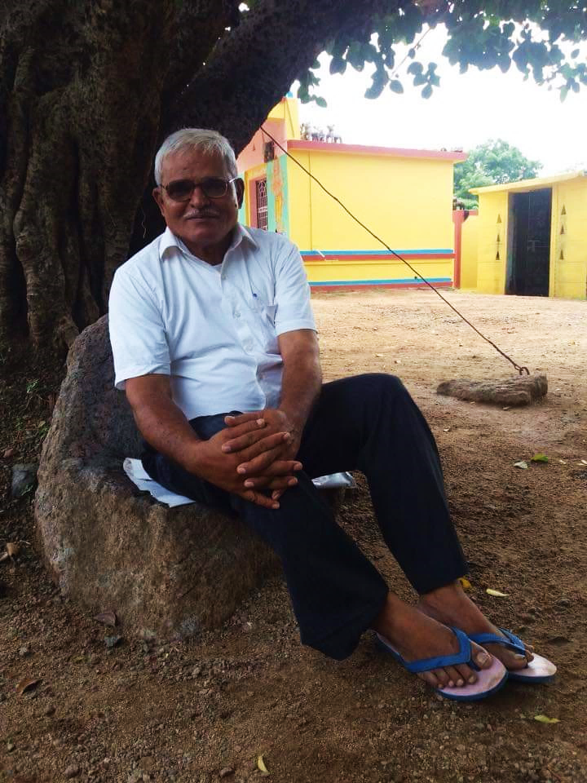
- “I was born in Dharmapuri, Tamil Nadu, in a small farming family. My father looked after goats but there was no school. He was very interested in learning so at the age of ten, he and some other boys went to a local man’s house to learn Tamil and to read and write. They would go there in the evening and use sticks and stones to write on a piece of broken mud pot. He would practice his writing on rocks in the forest while tending the goats. My father’s friends learnt from him, but his brothers and sisters were jealous and forced him to stop. So, my father said that if he had children, he would make sure they got education. As a result, I have three siblings who are all headteachers and their children are highly educated too. I was the first man from my village to go to college (when I was aged 19). I started studying at primary school which was near my house and then at high school which was 3 km away. On the 45-minute walk each way I used to read a book while walking. Eventually when I was about 13, I got a bicycle and was able to ride to school. That bicycle cost me 155 rupees (about £1.50). In primary school one teacher stands out as my model teacher, he had writing just like printing. He sang to us, and he told great stories. That same teacher attended my daughter Ramya’s wedding last year. I was a bit of a star pupil! I remember at one math’s test when I was in 6th standard helping the 8th standard to get their sums right. History and Math’s were my two favourite subjects. In history I love the stories of Freedom Fighters like Churchill and Abraham Lincoln. Most great warriors started life as simple people. Even the British Empire they helped the countries they conquered with education and good systems. I like leaders and their stories. When I was thirteen years old, I saw a boy fall from a tree. I took him on my bike to a government hospital on my own it was a long way, but the doctors appreciated my role, it was just my instinct. When I was just 6 years old, I was not interested to go to school and would rather play and stay at home with the freedom to run around. My father punished me when I did not go to school. On one occasion my father chained my leg to a huge log, and I could not move. Only after two days and two evenings did he let me free and only when I agreed to go to school. I remember my father would take poor people who had sickness over 200 km to a free hospital which was run by an American charity he would take them on the bus in groups. These are some of my memories from my childhood.”

