NOVEMBER 2021

Hello Friends. Whenever we speak with Venkat he asks us to pass on his heartfelt thanks to everyone who has made it possible for him to follow his life’s work in rural development in and around Mettupalayam. So, thank you!

Climate change.
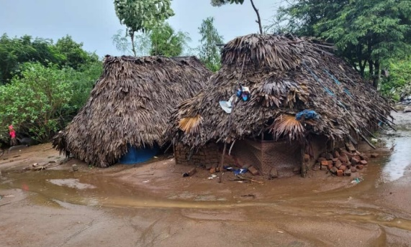
As we write, Tamil Nadu has been hit (again) by major flooding. Venkat can say with certainty that extremes of weather have become much more frequent in recent years. Chennai airport was closed with the runway under more than 6 feet of water. Of course, the flooding has hit the poorest worst. Of its 7.5 million population, 2 million live in severe poverty, often inhabiting areas close to lakes. Many houses are now under water.
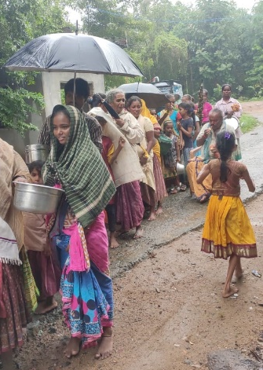
Around our project area lakes and wells are full to overflowing and we have just heard that heavy rain is falling again. Adele reminded us recently, that Mettupalayam means “higher place” and fortunately this and previous prevention work done by our project has meant that the buildings in Mettupalayam village are currently just about ok, but if the nearby lake area overtops then the village will flood.
The quarry group’s makeshift village, Ullampakam, has mud hut dwellings with palm leaf roofs (pictured above) and these became saturated letting water pour in. Venkat immediately arranged extra food support and then worked on temporary dry accommodation. This is where his 35 years of local knowledge and influence once again paid off. The area council, or Panchayat, has a new leader, who happens to be an ex-pupil of our Mettupalayam primary school.
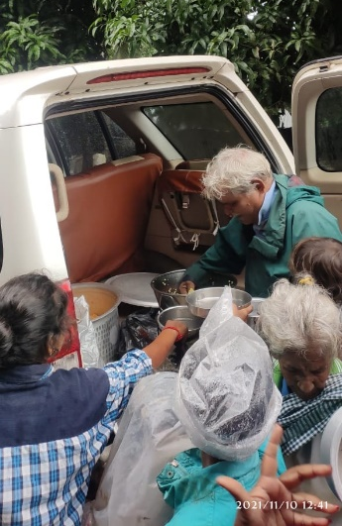
Her name is Gheeta and Venkat has been supporting her in studying rural development. Gheeta arranged for the Ullampakam villagers to have temporary shelter in the primary school building in the local village of Karani, until their own houses could dry out. Unfortunately, the owner of the building would only allow the tribespeople 3 days in the school, so Venkat has now moved most of the 60 villagers to our own school at Mettupalayam. He has allocated 2 classrooms and provided yoga mats for beds! With support from local friends, he is providing them with hot food (Venkat pictured here).Recognising that these extreme weather conditions are no longer a one-off, Venkat and Gheeta are approaching the local government to build proper concrete houses close to where the quarry group currently live. Money is apparently available to support tribal groups, so we are hopeful that this may be forthcoming. We will also work with him to see what further flood prevention measures can be made around the Mettupalayam village. Separately, Venkat is keen to take a lead in making sustainable changes at the project and to build an understanding of climate change into the school curriculum. His son, Anand, has purchased a solar panel that charges a battery for small items in the project building. Venkat would really like us to invest in a larger-scale solar energy approach, with panels probably on the school roof. This could power the school, lighting on the road outside the school and more. We have asked that they work up a proposal and we wonder if this might be a capital expense that any Friends or Friend might be interested in supporting? We will provide further information in due course but would be keen to hear your thoughts on this.
Other news
We are cautiously pleased to report that Covid 19 cases currently remain low in the area. We understand that 96% of the Mettupalayam villagers have had at least their first vaccine and are being actively encouraged to get second doses. Always ready to take an opportunity, Venkat also managed to get the Ullampakam villagers vaccinated when they were housed in their temporary accommodation! Whilst our schools at Mettupalayam and Nambikki have remained open, government schools had been closed throughout the pandemic. They opened recently, only to temporarily close again due the flooding.
Support for another poor tribal group at the nearby village of Manampathy has been ongoing, helped in large part by one generous Friend’s donations. Here, children have received extra teaching and regular nutritional food.

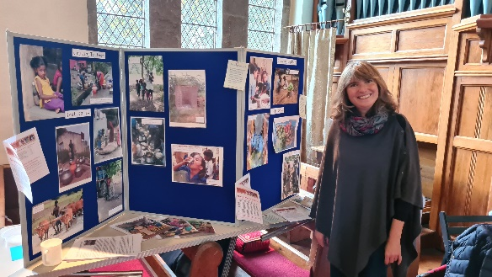
Fundraising and UK News
Fundraising has proved tricky again this year but there are Friends of Mettupalayam who are prepared to do some amazing, generous, kind and sometimes incredible things to support the charity and Venkat's work. Many Thanks to you all, including…two of Jean and Hugo’s daughters, Sarah and Jennifer, who completed a Half Iron Man (mad girls); the congregation at Pickhill church who have generously continued their annual donation; and Liz Ramsay and friends who organised a lovely community event and coffee morning at Crakehall church – all raising amazing and much needed funds.
In the spirit of Growing Together, trustees and friends spent a wonderful day planting over a thousand bulbs in Chris and Alison's new orchard.
The weather was kind to us and payment for our labours took the form of tasty soup, made with homegrown veg, fantastic cake and another generous donation to the project.
Growing Together can be accessed via Facebook and is a secure online forum for people sharing garden and growing experiences both in Mettupalayam and the UK.
Although it will be a little more dormant over the Winter it is hoped that it will 'Spring' into a new growing season next year with even more energy and fundraising potential in 2022.
Thank you all for your continued interest and support and we wish everyone here and in Mettupalayam a Merry Christmas and a Happy New Year
.Contact us:
Adele Eldridge Francis and Rosie Muncaster Hugo and Jean Welsh
01969 650618 01677 425961 07802641073
adeleeldridge@gmail.com fmuncaster@hotmail.com hugo.welsh30@gmail.com

