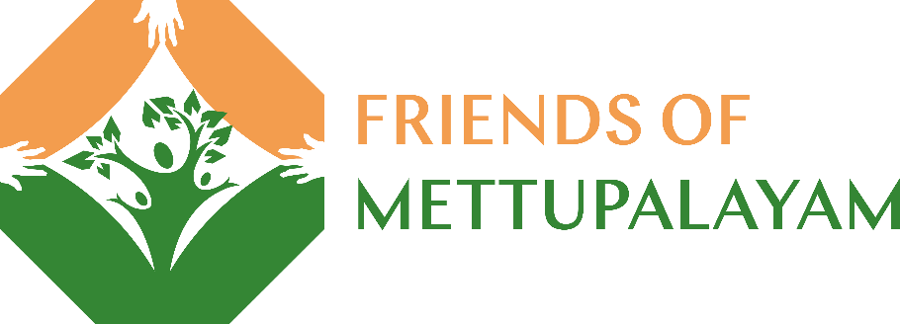
Our FOM Autumn Quiz - Answer Sheet
Section 1 Plants and Flowers
- What is the first flower of the year to bloom in the wild in England.
2. What is the difference between the native British blue bell and the Spanish bluebell?
3. What colour flower do you find on wild garlic?
4. Cow parsley is a member of what vegetable family?
5. What is Rosa canina better known as?I
6. What yellow plant can cause liver damage to horses and cattle
7. What plant produces an important heart medication but is poisonous if consumed to excess
8. What bulbs were once more valuable than gold in holland?I
9. what four things do all plants need?
10. Can you eat all the rhubarb plant?

Answers
1. Snowdrop
2. The Spanish is more upright and does not hang to the side. It also has wider leaves.
3. White
4. Carrot family
5. Dog rose or wild rose
6. Ragwort
7. Foxgloves
8. Tulips
9. Sun, air, water, food
10. No, the leaves contain oxalic acid that is harmful to humans

Section 2 Try and guess these record-breakers
What is…
1 The longest cucumber.
2 The heaviest carrot.
3 The longest parsnip.
4 The heaviest marrow.
5 The longest runner bean.
6 The heaviest leek.
7 The most popular fruit in the world.
8 The heaviest potato.
9 The tallest sunflower.
10 The heaviest pumpkin
Answers.
1. 130.5 cms
2. 9.07kg (20lbs)
3. 5.7m (19ft 2in) size of the average giraffe!
4. 93.4kg (206lbs) size of the average dolphin.
5. 1m 30cms (4ft 3in) height of the average nine year old.
6. 9.75kg (21.5 lbs) Grew listening to Glen Miller music
7. Tomato
8. 4.98kg (10 lbs 14 oz). Weight of the average domestic cat
9. 9.17 m (30 ft 1 in)
10. 1,190.5 kg. (2,624.6 lbs)

Section 3 Autumn Dingbats
1. What is the covering of the Roe Deer's new antlers that start to form in Autumn? V
2. Singer of the War of the World's hit 'Forever Autumn' JH
3. A sloe is the fruit of this plant. B
4. Leader of the Gunpowder Plot. RC
5. Wednesday 22nd September 2021 is ..... AE.
6. In Autumn Geomagnetic storms cause the natural phenomenon AB
7. Which bird's migration takes them 11.000 miles? AT
8. The Knot migrates to Britain in Autumn where it is seen feeding at the edge of the tides. It derives its name from KC.
9. The author of the poem 'To Autumn' JK
10. What is the full moon closest to the Autumn Equinox known as HM

Answers

1. Velvet
2. Justin Hayward
3. Robert Catesby
4.Blackthorn
5. Autumnal Equinox
6. Aurora borealis
7. Artic Tern
8. King Canute
9. John Keats
10. Harvest Moon

Section 4 Trees
- Which trees shed their leaves in autumn? Deciduous trees, evergreen trees or Christmas trees?
- Many leaves turn orange in Autumn. What pigment causes this? Is it, melanin, chlorophyll or carotene?
- What is the nickname given to the seeds that fall from sycamore and ash trees? Is it, spinning seeds, whirly seeds, top seeds, helicopter seeds or spiral seeds?
- From which tree do conkers fall?
- This tree has red or orange berries and is known as the mountain ash. Do you know its other name?
- Trees use sunlight to turn water into… leaves, bark, wine, or oxygen?
- What is the other name for the colourful Acer tree?
- What is the process in question 6 called?
- What is the fruit called of the tree which is the emblem of the National Trust?
- Which liquid can help make a conker tougher (and win more games)?
Answers
- Deciduous
- Chlorophyll
- Helicopter seeds
- Horse chestnut
- Rowan Tree
- Oxygen
- Sycamore
- Photosynthesis
- The acorn
- Vinegar

