The Spring Quiz – And Answers!

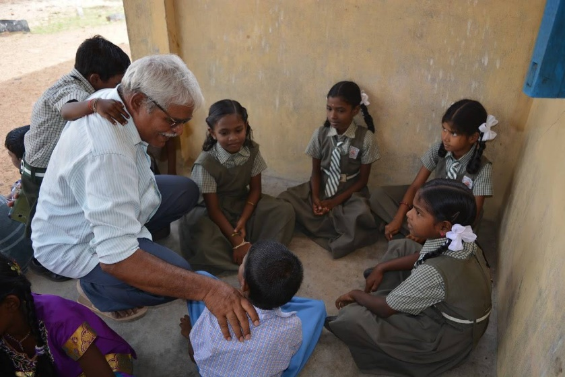
Friends. We hope this quiz helps lift you out of the lockdown blues and towards a brighter summer. If you feel like making a small donation to support our work in Tamil Nadu, please go to our “donate now” button on the website. Every penny goes to be spent where it is needed. Thank you, have fun and good quizzing!

Who / Where / What / When – An Easter starter
- Star struck couple would hear of Easter for the first time – maybe on a balcony – who?... Romeo and Juliet (the only Shakespeare play to mention Easter)
- These inhabitants can never see their national flag – who?... Easter Island
- Were these first supplied Bristol-fashion, or sunny side up – who?... Fry’s confectioners of Bristol – who produced the first chocolate Easter Egg
- An oval but thorny weight – what?... Thorn..Tons easter egg
- Too good to eat, this odd-shaped bounder should not be interred – what?... Cad..Bury easter egg
- Does this festival have any pancakes – when?... Mardi Gras
- These flowers may not be in season, but a box I am sure would be appropriate – what?... Cadbury’s Roses
- Do not make a song and dance of it, but it was a 1948 film – what?... Easter Parade
- A burning, irate, top-knot – what?... A hot-cross bun
- A must-wear accessory, at this time – what?... An Easter Bonnet

Flowers

- What is the common name for any of the plants that fall into the genus Narcissus? … Daffodils
- What does the term perennial mean? … returning each year.
- Which flower is often called the 'winter rose' or 'Christmas rose'? … Hellibore
- Which blue flower of the genus Veronica is also the name of the ship which was to accompany the Mayflower with the Pilgrim Fathers? … Speedwell
- Saffron comes from which type of flower? … Crocus
- I am the flower emblem for Yorkshire? … White rose
- Which part of the flower is the Corolla? … The petals
- Which flower is the most popular to purchase? … The rose
- What would you find in an anther on a stamen? … Pollen
- What is the common name for the antirrhinum? … Snapdragon

Sweets

- Where 9,10 and 11 come …After Eight
- A French man is very happy… Bons Bons
- Bowling target…Skittles
- Many a first attraction decided with these… Love Hearts
- Don’t get these in a twist…Snickers
- Royal producer of money… Mint Imperials
- Not for a white shirt on a hot day… Chocolate Buttons
- Wise guys, know it alls… Smarties
- A price on its head… Bounty
- Sponge for an afternoon tea in Yorkshire… Pontefract Cakes
- It’s not a big splash… Ripple
- Ascot’s language… Tic Tacs
- Where mums go for a drink… Mars Bar
- A noisy insect… Humbug

Sport

- What is the name of the biennial golf competition between the USA and Europe?... The Ryder Cup
- How many players are there in a basketball team?... Five
- In what sport do they use a chuck?... Ice Hockey
- Can you name a royal who has won an Olympic medal?... Zara Philips,
- Which famous golfer played out of a tree at Fulford golf club?... Bernhard Langer
- Over how long is the Grand National run?... Four miles (2.5 furlongs)
- How many hoops are there in a game of Croquet?... Six
- What is known as the “roarin’ game” (clue, it originated north of the border)?... Curling
- Which team has won the FA cup most times?... Arsenal (14) [MU are second (12)]
- In which sports would you hear about a punt?... Rugby (kicking the ball)

Pairs
The following are well-known pairs, but who or what are they? The numbers indicate the number of letters in each word.
- M + S… 5/7… Marks and Spencer
- T + J …3/5… Tom and Jerry
- P + J …5/4… Punch and Judy
- L + M …6/9… Lennon and McCartney
- B + R …6/5… Batman and Robin
- J + J …4/4… Jack and Jill
- T + T …10/10… Tweedledum and Tweedledee
- J + H …6/4… Jekyll and Hyde
- L + L …6/5… Little and Large
- H + G …6/6… Hansel and Gretal
Birds
- Give three reasons why a woodpecker pecks at a tree… To attract a mate, dig a nest hole and for feeding.
- Which British bird has the largest wingspan?... The Mute Swan
- Which unusual visiting bird spent last summer in the Derbyshire Dales?... The Bearded Vulture
- In which of these months would you be least likely to hear a robin sing?
a) March
b) July
c) October
- Which bird is on the logo of the RSPB?... The Avocet.
- Nuthatches and Treecreepers mostly feed from under the bark of trees. One of these two species feeds in an unusual way. Which one is unusual and why?... The Nuthatch. It walks down the tree feeding with its’ head towards the ground.
- Where do Shelducks build their nests?... In empty rabbit holes.
- Which bird was the most commonly observed species during this year's RSPB Big Garden Birdwatch?... The House Sparrow.
- Which is the smallest resident British bird?... The Goldcrest.
- Which bird has the longest annual migration of any animal in the world?... The Arctic Tern.

Thank you for taking part and do let us know how you scored!
In the Contact Us section of our menu, you can use the pro-forma or go direct to one of the Trustees whose contact details are supplied. Or you may want to comment on our Facebook page.

