Special Covid 19 Update, 5 May 2021
Hello Friends,
Given the dreadful news coming from India in recent days, we felt it appropriate to provide you our most up-to-date information from the project. The trustees held a video call today with Venkat and his son Anand. Here are the key facts and outputs from that discussion:
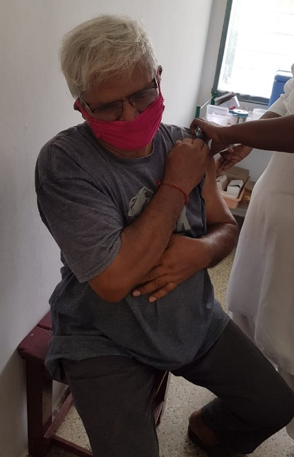
- The situation in Tamil Nadu is worsening significantly. A few weeks ago, there were 400 cases per day. This has now increased to 22,000 per day.
- At present, the position is most serious in the cities, but this is beginning to spread to rural areas.
- Belatedly, a state-wide lockdown has been ordered from 6 May and there is talk of a national lockdown. As we know, lockdowns cause other pressures on low-income areas like Mettupalayam.
- Venkat has had both vaccine jabs, which is great news. However, he is very much in the minority. There are vaccine supply issues and there is a serious issue in terms of “vaccine hesitancy”. Culturally there is a reluctance to be vaccinated, with many thinking they will rely on natural remedies. Additionally, Venkat tells us that there has been a lot of television reporting against the vaccine. We recognise this issue from our own experience, that the risk/benefit arguments are complex and that Venkat cannot just instruct people that they must take the vaccine.
Venkat and Anand are preparing actions to support the local community against the devastating second wave that seems to be rapidly approaching the area.
- They are preparing evidence-based pamphlets for distribution.
- They will distribute free face masks at meeting points around the vicinity.
- They will provide transport to vaccination centres as necessary.
- They will pay for vaccination as appropriate for those who are not yet in the eligible age-groups.
- They are preparing to support those in need in whatever ways needed.
The position is precarious, and we will remain in constant contact with Venkat. As Trustees, we have pledged whatever support is needed during this emergent situation, just as we did during the lockdown last year. Venkat sends his heartfelt thanks for the support you give, which has made such a difference to so many over the years and surely will over the coming months.
Thank you.
Contact us:
Adele Eldridge Francis and Rosie Muncaster Hugo and Jean Welsh
01969 650618 01677 425961 07802 641073
adeleeldridge@gmail.com fmuncaster@hotmail.com hugo.welsh30@gmail.com

