The Spring Quiz

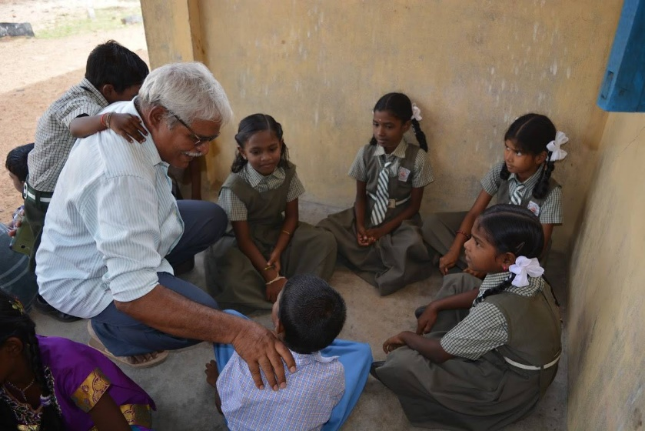
Friends! We hope this quiz helps lift you out of the lockdown blues and towards a brighter summer. If you feel like making a small donation to support our work in Tamil Nadu, please go to our “donate now” button on the website. Every penny goes to be spent where it is needed. Thank you, have fun and good quizzing!

Who / Where / What / When – An Easter starter
- Star struck couple would hear of Easter for the first time – maybe on a balcony – who?
- These inhabitants can never see their national flag – who?
- Were these first supplied Bristol-fashion, or sunny side up – who?
- An oval but thorny weight – what?
- Too good to eat, this odd-shaped bounder should not be interred – what?
- Does this festival have any pancakes – when?
- These flowers may not be in season, but a box I am sure would be appropriate – what?
- Do not make a song and dance of it, but it was a 1948 film – what?
- A burning, irate, top-knot – what?
- A must-wear accessory, at this time – what?

Flowers

- What is the common name for any of the plants that fall into the genus Narcissus?
- What does the term perennial mean?
- Which flower is often called the 'winter rose' or 'Christmas rose'?
- Which blue flower of the genus Veronica is also the name of the ship which was to accompany the Mayflower with the Pilgrim Fathers?
- Saffron comes from which type of flower?
- I am the flower emblem for Yorkshire?
- Which part of the flower is the Corolla?
- Which flower is the most popular to purchase?
- What would you find in an anther on a stamen?
- What is the common name for the antirrhinum?

Sweets

- Where 9,10 and 11 come.
- A French man is very happy.
- Bowling target.
- Many a first attraction decided with these.
- Don’t get these in a twist.
- Royal producer of money.
- Not for a white shirt on a hot day.
- Wise guys, know it alls.
- A price on its head.
- Sponge for an afternoon tea in Yorkshire.
- It’s not a big splash.
- Ascot’s language.
- Where mums go for a drink.
- A noisy insect.

Sport

- What is the name of the biennial golf competition between the USA and Europe?
- How many players are there in a basketball team?
- In what sport do they use a chuck?
- Can you name a royal who has won an Olympic medal?
- Which famous golfer played out of a tree at Fulford golf club?
- Over how long is the Grand National run?
- How many hoops are there in a game of Croquet?
- What is known as the “roarin’ game” (clue, it originated north of the border)?
- Which team has won the FA cup most times?
- In which sports would you hear about a punt?

Pairs
The following are well-known pairs, but who or what are they? The numbers indicate the number of letters in each word.
- M + S… 5/7
- T + J …3/5
- P + J …5/4
- L + M …6/9
- B + R …6/5
- J + J …4/4
- T + T …10/10
- J + H …6/4
- L + L …6/5
- H + G …6/6

Birds
- Give three reasons why a woodpecker pecks at a tree.
- Which British bird has the largest wingspan?
- Which unusual visiting bird spent last summer in the Derbyshire Dales?
- In which of these months would you be least likely to hear a robin sing?
a) March
b) July
c) October
- Which bird is on the logo of the RSPB?
- Nuthatches and Treecreepers mostly feed from under the bark of trees. One of these two species feeds in an unusual way. Which one is unusual and why?
- Where do Shelducks build their nests?
- Which bird was the most commonly observed species during this year's RSPB Big Garden Birdwatch?
- Which is the smallest resident British bird?
- Which bird has the longest annual migration of any animal in the world?

Thank you for taking part. We will post the answers on the website a week after the Easter break

