March 2021

Hello again Friends. The last 12 months has given all of us reason and time, to pause and reflect. We have dedicated this newsletter to some reflections from our co-founder Adele - followed by a few ideas for some much-needed fundraising which we would love you to join in with.

From Adele “The Pandemic has challenged each and every one of us in very different ways. This may have meant dealing with loss in one form or another or giving us different and greater responsibilities through work and home schooling. It has prompted us to evaluate and perhaps reimagine new ways of working and living as we move forward. This is equally true for Venkat and people in Mettupalayam,
During most of last year Venkat and the teachers at the school have worked incredibly hard on the Food Aid Programme, distributing, in the end, £22,000 worth of much needed food to people in the surrounding area. This has had a massive impact on people’s health and ability to survive. Looking a little beyond the village, more tribal people have been identified living in very difficult circumstances and needing support.
A few weeks ago, through the wonders of technology, we were able to have a Trustee Zoom meeting with Venkat. It was great to see him and his son Anand looking so well.
Although it was Sunday there were children about who sang us a heart-warming song. Just delightful. We got on to talking about Venkat’s plans, one of which concerned continued training for a local tribal girl to nurse and provide basic health support to villagers between clinics run by the doctor. Another was a Kitchen Garden project to provide seed and knowhow to encourage women’s groups and families to grow their own vegetables. This will, of course, benefit nutrition and perhaps alleviate the food situation in any subsequent lockdowns. There were other ideas too! He then talked about the situation of tribal people living 5km from Mettupalayam in the direction of Manampathy, the local market town.
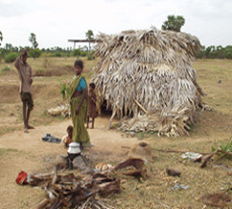
“You know Adele, it really is like Mettupalyam thirty years before…” With that sentence I was transported back to late 1993 when David and I arrived in the village. A Mettupalayam with no clean drinking water or latrines, a small, dark, school building not able to house the children attending, teachers who had pawned jewellery to buy a sack of rice for school dinners, a meal that for many children was their only meal of the day. A Mettupalayam where anyone over the age of ten was illiterate and innumerate, where one or two tribal children attended school and walked back to their colony in the evening to teach their elders how to write their names. Where children died because they were beaten with sticks to excise evil spirits rather than accessing basic health care and knowledge. Where people couldn’t access government entitlements because, as far as records were concerned, they didn’t exist. Where people lived in mud walled huts prone to rats, snakes and being washed away in heavy rains.
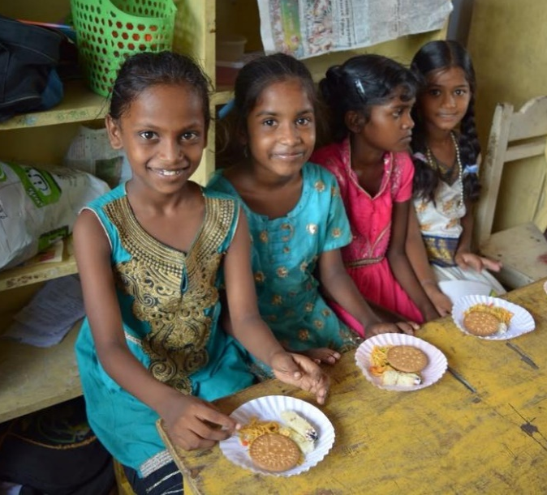
I could go on, there have been so many issues that have been overcome or improved and so many success stories for individuals and groups over the years. As I listened to Venkat’s proposals for the tribal village and the vitality and assuredness in his voice, I had an overwhelming awareness that this is what success looks like. A lifetime of dedication and experience, insight and understanding of people and need, ready, on hand for those who require help. A man and a village with resources in its buildings, infra-structure and people - ready to push their sphere of influence and help others in this neighbourhood.
Venkat finished his conversation by saying how lucky he was to have found Friends in the UK who have supported his efforts over the years and made such changes possible.

I would like to say thank you to every person who has ever bought a tee shirt, Christmas decoration, attended a coffee morning, bought a ticket, sung a carol, walked or cycled a mile, made a donation, completed a direct debit or more recently downloaded a quiz. Your giving has been generous and truly life changing. We can continue to make a difference. We all need to recognise and hold on to that knowledge as we move on into 2021.”
Fundraising.
Thanks…
- Despite the limitations on all our lives right now, generous friends have been finding ways to spread awareness of the project. Our thanks go to all those who have encouraged friends to make gifts to FOM as a way of celebrating Christmas, birthdays and milestone anniversaries. It is indeed true that it is impossible to give without truly receiving.
- In an attempt to live more clutter free, one industrious couple cleared their attic and put items on a local Buy Swap Sell site. Items were offered as free to a good home, but with the suggestion that donations could be sent to FOM via the website and Donate Now button. Thanks Catherine and Lawrence, an inspirational idea to help us all engage with Spring Cleaning and living more simply.
And some more ideas…
- On the website there is a gorgeous leaflet prepared by our friend Nikki, with a series of Mettupalayam curry recipes for download with a slideshow and some suggestions for holding a Curry Night. Keep it in the family, encourage the children or invite a couple of friends when lockdown measures allow.
- The Christmas Quiz was well received and seemed to prompt some interesting family discussions so a loosely Spring-based quiz can be downloaded too. Just go to https://irdt.co.uk/fundraising/ for the curry night leaflet and the quiz.
- Venkat is working on developing kitchen gardens around Mettupalayam. So, we are launching “Growing Together”, to encourage people here to be involved at any level. It is hoped that we can share our gardening experiences and raise some money for FOM into the bargain. If you or anyone you know is interested, especially perhaps schools and community groups, please contact Adele on the details below.
As always thank you so much for your continued interest and support. Stay safe and well.
Contact us:
Adele Eldridge Francis and Rosie Muncaster Hugo and Jean Welsh
01969 650618 01677 425961 01904 769248
adeleeldridge@gmail.com fmuncaster@hotmail.com hugo.welsh30@gmail.com

