November 2020

Hello Friends,

As we look forward to a rather uncertain Christmas period, we hope this newsletter makes you proud of the support your charity has provided to so many people around Mettupalayam during this global crisis.

The Pandemic
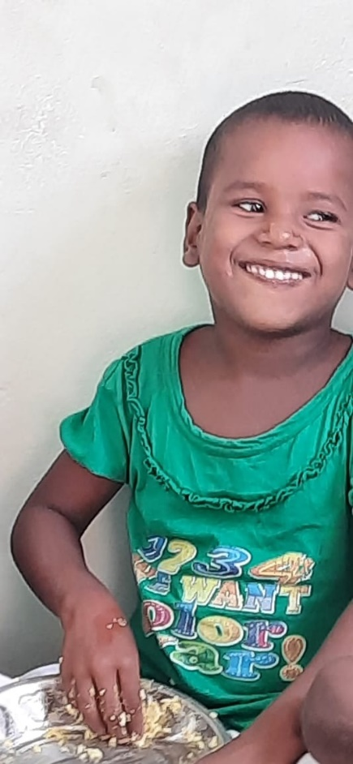
The restrictions on work and travel in Tamil Nadu have meant that many breadwinners have been out of work and without the money to feed their families - unlike here, working from home is rarely an option. The government has provided some very basic food aid (rice, dahl, cooking oil and sugar) for those with ration cards, but as you know, many of those we support are from communities and castes who do not have the necessary papers.
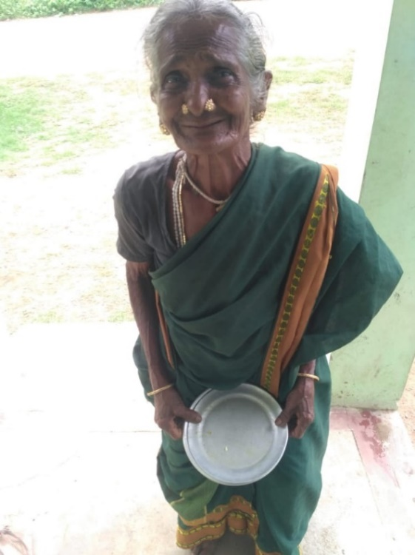
So, with Venkat’s expert local knowledge, we have targeted those in need with our Food Aid programme. Initially, this was through the supply of vegetables. Queues would form several hours before delivery times. Since September, as the situation has stabilised a little, we have cooked and delivered daily lunches to a carefully selected group of around 350 of the most vulnerable people in five local villages. Designed and coordinated by Venkat and his son Anand, the programme has been supported by our teaching staff. We can only imagine some of the logistics and challenging decisions on priorities that they had to overcome. It is something that only a project with the level of longstanding local knowledge, respect, and relationships like ours could have achieved.

Our photos here capture how your support is making such a positive difference at two ends of the age spectrum. Kanakavalli is five years old and joins our 1st standard class this year. Her older sister has just finished our 7th standard. Kana has a dream that she will become a teacher. Muthammal is believed to be 85 years old. She has had a hard life doing rural labour and has depended on our food aid during the current crisis

Unfortunately, the extra financial support required for the current programme is not something FOM can maintain into 2021. But there is good news. A general election is around the corner!! (May 2021) and local politicians are introducing an increased level of guaranteed rural employment work at an improved daily wage rate. In addition, they have pledged to provide a mobile ration shop van to deliver to Mettupalayam and local villages every two weeks. We are also encouraged to hear that Covid 19 cases and deaths are presently falling in Tamil Nadu and the local area. This has resulted in the re-opening of our local Manampathi market, which has been closed since April.
All this means that Venkat will be able to refine the food aid support yet further as we move towards the end of the year and into 2021

Education

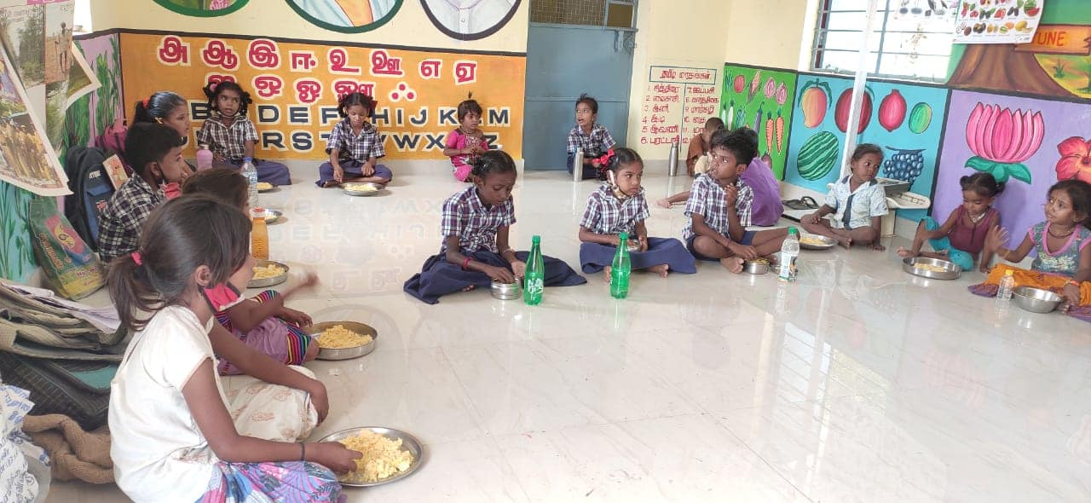
State schools in Tamil Nadu have been closed, but we are delighted that Venkat and the teachers have kept our classes running with the agreement of the local education officer. This has been done to avoid large groups and travel by delivering lessons in three local villages as well as at Mettupalayam. Where there’s a will, there’s a way!

Fundraising

The pandemic has made some fundraising events impossible, so we have a new idea this year – a Prize Christmas Family Quiz! We hope this will add some fun to a Christmas time which we know will be different this year. Please pass this on to your friends and neighbours too. The money voucher prizes have been donated by a very generous friend, so that every suggested £2 entry fee will go straight to the charity. To access the quiz please go to the attached link to our website at http://irdt.co.uk/fundraising/ If you cannot access the internet, please contact any of the Trustees and we can provide a copy for you. Please email or post your completed quiz to Adele Eldridge (details below) by 5 January 2021. Good luck and thank you.

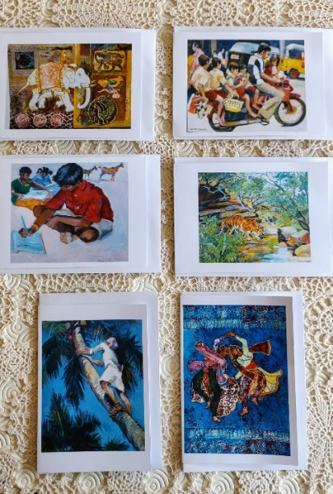
The beautiful greeting cards produced from the paintings of our dear friend Susan Sands are blank inside, so make an ideal Christmas or New Year card. Please contact Francis (contact details below) if you would like some. The cost is £5 for a pack of 6 assorted cards, plus postage, with all the proceeds to the charity.

Adele has told us that the members of a book group she belongs to save through the year for a Christmas lunch. As they will not this year be able to meet as a group, they have decided to donate their savings (£400) to FOM. Wow! If you have any ideas of your own for fundraising please let us know and we can share these on our Facebook page.

We all want to support our local shops, but if you decide to use amazon please use smile.amazon.co.uk and nominate Friends of Mettupalayam as your chosen charity.

We often speak to Venkat and thank him and his team for their wonderful work. However, he always says that without his friends in the UK nothing is possible. Your support and friendship keep the project going and is more appreciated than ever. Thank you and we wish you and your families a very Merry Christmas and a Happy New Year.
Contact us:
Adele Eldridge Francis and Rosie Muncaster Hugo and Jean Welsh
01969 650618 01677 425961 01904 769248
adeleeldridge@gmail.com fmuncaster@hotmail.com hugo.welsh30@gmail.com
The Coach House, Leyburn
DL83EE

